NIV MEMORY VERSE: Joshua 24:15 EXODUS & POSSESSION 23-1
". . . choose for yourself this day whom you will serve,
. . . But as for me and my household, we will serve the Lord."

"INHERITING THE LAND"
Joshua 11:1-24:33

1. What was significant to you in last week's lesson?

DAY 1 READ Joshua 11:1-12:24
2. a. After defeat of the southern cities, the northern cities gathered under the leadership of king _____________________ to go against Israel.
b. What was the result of the battles from 11:6-15?

- Why was Israel so successful according to 11:20?

3. a. What was the outcome of Joshua's battle with the Anakites?

b. The first time the Israelites spied out this land the Anakites (Numbers 13:30-33) had brought fear because of their great size. With help from the Lord now the victory was won. What giants in your life have yielded through your faith in Jesus?

4. What was the result of the northern battle campaign?

5. a. Scan Joshua 12. How many kings did the Israelites conquer to the west of the Jordan?

b. Why do you think specific names and places are important in the Bible?

DAY 2 SCAN Joshua 13:1-21:45
6. What did the Lord say to Joshua?

7. When the Tent of Meeting was relocated from Gilgal to Shiloh Joshua cast lots before the Lord to complete the land distribution. (18:1-10) Fill in the map below with the letter representing the name of the tribe by using a map in the back of your Bible or some other source showing tribal inheritance.
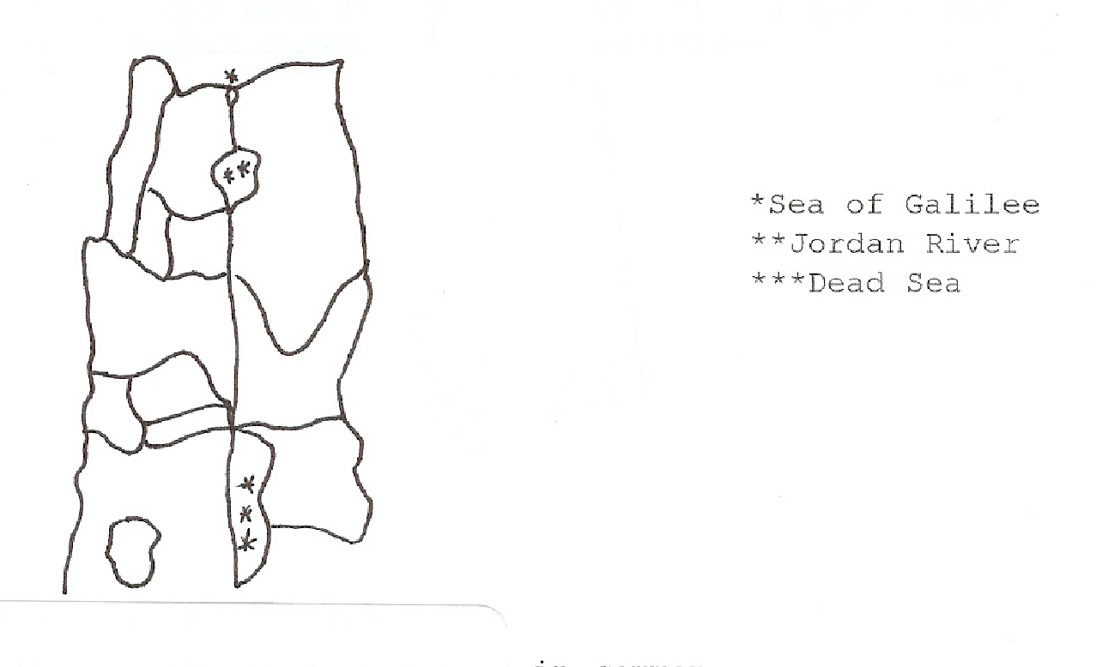
a. Asher (19:24-31)
- Naphtali (19:32-39)
- East Manasseh (13:29-31)
d. Zebulun (19:10-16)
e. Issachar (19:17-23)
f. West Manasseh (17:1-18)
g. Dan (19:40-48)
h. Ephriam (16:5-10)
i. Benjamin (18:11-28)
j. Gad (13:24-28)
k. Judah (15:1-63)
l. Reuben (13:15-23)
m. Simeon (19:1-9)

EXODUS & POSSESSION 23-2
DAY 2 (Continued) SCAN Joshua 13:1-21:45
8. Why was Simeon given land within Judah (19:1,9)?

9. Review these verses and relate briefly what they have in common.
(13:13, 15:63, 16:10, 17:12)

10. What inheritance was given to Joshua in 19:49-50?
11. Identify the six Cities of Refuge named in 20:7-9.

12. How many cities (21:41) were established by the Levites?

13. Consider Caleb and his inheritance (14:6-15; 15:13-19). What do you admire about him?

DAY 3 READ Joshua 22:1-34
14. a. Having fulfilled their obligation to help possess the land, the Reubenites, Gadites and half- tribe of Manasseh returned home. What did they build in vs.10?

b. What action did the other tribes take?

15. a. Summarize the allegation made by the delegation sent to intervene.

b. According to the Reubenites, Gadites, and half-tribe of Manasseh, why was the altar built?

c. How then did the priest and sons of Israel respond in verse 30?

d. What was their altar called?

16. Unity for God’s people has always been the goal (John 17:20,21).
a. In what ways can we promote unity? (see Ephesians 4:1-7)

b. In what ways are we one?

DAY 4 READ Joshua 23:1-16
17. a. To whom did Joshua speak?

b. In Joshua's speech what did he tell the Israelites concerning . . .
. . . the Lord's part?

. . . the Israelites' part (vs. 6-11)? List at least five.

. . . the consequences?

EXODUS & POSSESSION 23-3

DAY 4 (Continued) READ Joshua 23:1-16
18. Joshua warned them that temptation would not cease once settled in the Promised Land.
How does a Christian remain faithful in the face of temptation?

DAY 5 READ Joshua 24:1-33
19. What do we learn about the "fathers" in verse 2?

20. In verses 5-13 Joshua reviewed Israel's history. Choose one incident and share how you
are able to apply its lesson to your life.

21. a. What choices did Joshua give the people?

b. What was Joshua's choice?

c. What was the people's choice?

22. Joshua made a covenant with the people that day. What was a witness of that covenant?

23. Where were the following men of God buried:
a. Joshua?

b. Joseph?

c. Eleazar?

24. This is the last lesson in the book of Joshua. How do you think this book helps us be
successful in the battles of life?

EXODUS & POSSESSION 23-4

"INHERITING THE LAND"
Joshua 11:1-24:33

LECTURE NOTES:

PRAYER REQUESTS:

