GIDEON - Judges 6:1-8:35

NIV MEMORY VERSE: Judges 8:23 But Gideon told them, "I will not rule over you, nor will my son rule over you. The Lord will rule over you."

- Content: the cyclical narrative of the time of the judges, with emphasis on Israel’s repeated lack of covenant loyalty
- Historical coverage: from the death of Joshua to the beginning of the monarchy
- Emphases: the tenuous results of the conquest; God’s constant rescue of his people, despite their habitual failure to keep covenant with him; the desperate conditions and overall downward spiral during this period; the need for a good king

The introduction to the narrative is in two parts.

SLIDE: Part 1 (1:1—2:5), which picks up and enhances some of the conquest narrative from Joshua, has two emphases, both found in the conclusion (2:1-5):

BUILD: that God did not break covenant with Israel, but that they broke covenant with him by not driving out the Canaanites (1:21, 27-36), and
BUILD: that God will no longer come to their aid in this cause; instead, the Canaanites “will be thorns in your sides and their gods will be a snare to you” (2:3). Thus this part gives the basic reason for what follows.

SLIDE: Part 2 (2:6—3:6) rehearses in summary form how the narrative will unfold. Here the basic cycle is introduced:
- Israel does evil in the eyes of Yahweh by serving the Canaanite Baals (SIN) (2:11-13).
- They experience Yahweh’s anger in the form of failure in battle and oppression by their enemies (SERVITUDE) (vv. 14-15).
- The people cry out in their distress, and God rescues them by sending a judge-deliverer (SUPPLICATION) (v. 18B).
- God rescues them by sending a judge-deliverer (SALVATION) (v. 16).
- While the judge lived, there was peace (SILENCE) (v. 18). When the judge dies, the cycle begins all over again (w. 17,19-23).
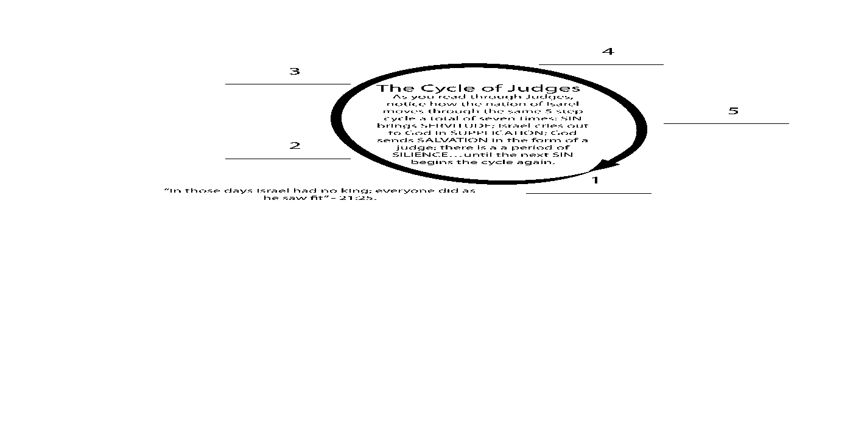
SLIDE: After Joshua makes his pronouncement that “he and his household would serve the Lord”, the crowd joins and states,

"Far be it from us to forsake the LORD to serve other gods! It was the LORD our God himself who brought us and our fathers up out of Egypt, from that land of slavery, and performed those great signs before our eyes. He protected us on our entire journey and among all the nations through which we traveled. And the LORD drove out before us all the nations, including the Amorites, who lived in the land. We too will serve the LORD, because he is our God” (Josh. 24:15-18)

What happened? What brought about such a drastic shift?

Typically the pattern goes like this:

BUILD: From bondage > spiritual faith, from spiritual faith > great courage, from great courage > liberty, from liberty > abundance, from abundance > leisure, from leisure > selfishness, from selfishness > complacency, from complacency > apathy, from apathy > dependency, from dependency > weakness, from weakness back to > bondage.

It happened then, it can happen today.

As we read through Judges, we need to remember that chronologically, we are on an unrelenting deterioration of things in Israel down to the time of Samuel.

Thus, the portrayals of Othniel, Ehud, and Deborah are basically positive, we’ve seen that. But beginning with Gideon, things begin to tilt. The Gideon story begins well, but turns out badly in the form of an idolatrous ephod (pronounced eh•faad) (8:24-27) and a murderous son, Abimelech (ch. 9). You’ll turn there next week.

Note: (NIV Biblical Theology Study Bible) ephod. A garment worn primarily by the high priest (Exod 28:6–14; 39:2–7) but later also by King David (2 Sam 6:14; 1 Chr 15:27). It was sometimes associated with divining the will of God (1 Sam 23:9–10; 30:7–8; Hos 3:4). Archaeology has shown that this is a garment that also adorned male idols; therefore, it is likely used here as a euphemism for an idol, since all Israel “prostituted themselves” to it (i.e., worshiped it). Due to the amount of gold used, the “ephod” figuratively represents not only the garment that clothed a sacred image but also the image over which the garment was draped. Since Gideon was neither a priest nor a king, he had no business making an ephod. It was placed in Ophrah, his hometown, where his father’s Baal altar and sacred (“Asherah”) pole had been located. All Israel prostituted themselves. As the Israelites had prostituted themselves to the deity Baal (v. 33; 2:17), they prostituted themselves to the ephod made by Gideon. They worshiped an idol made by their own judge. and it became a snare to Gideon and his family. Tragically, Gideon enticed himself and his family away from the Lord with this idol (cf. Deut 12:30)

SLIDE: A Quick Overview of Gideon

BUILD: As chapter six opens, here begins the cycle…Again the Israelites did evil in the eyes of the Lord” (6:1). The oppression is from hordes of easterners, led by Midian and Amalek, and is particularly desperate (6:2-6, they ruined the crops and did not spare a living thing for Israel) so that Israel cries out to God, who again reminds them that they have broken covenant with him (6:7-10). But the greatest elaboration is with the deliverer Gideon and the tale of victory.

BUILD: Gideon is portrayed as fearful and lacks confidence (6:11-19), obedient but doubting (6:20-40). He starts well—by tearing down the altar of Baal (6:24-32) and “leading” a decisive, God-orchestrated victory over Midian (ch. 7). But then a quite different Gideon pursues Zebah and Zalmunna (8:1-18); nonetheless, even though his zeal represents something of a personal vendetta over the death of his brothers (8:19-21), he is still pictured as carrying on the holy war. But he ends up making an ephod that becomes idolatrous as we’ve seen.

BUILD: Key to this episode is the demand of the Israelites that Gideon rule over them (8:22), which he rejects—a rejection that includes his sons— in favor of the rule of Yahweh (v. 23).
SLIDE: A Deeper Dive - Gideon’s Story
SLIDE: As we mentioned, the Israelites are suffering under an oppressive regime — in this case, the Midianites — they again repent and cry out to the Lord. This time God chooses Gideon to deliver them from their oppressors.
Remember the guy in high school who everyone thought was, “Least Likely to Succeed”? This is our hero, Gideon. Even he is surprised when God gives him the prestigious assignment of saving the nation.
Let’s pick up the story in Chapter Six…
BUILD: ¹¹ The angel of the Lord came and sat down under the oak in Ophrah that belonged to Joash the Abiezrite, where his son Gideon was threshing wheat in a winepress to keep it from the Midianites. ¹² When the angel of the Lord appeared to Gideon, he said, “The Lord is with you, mighty warrior.”
BUILD: ¹³ “Pardon me, my lord,” Gideon replied, “but if the Lord is with us, why has all this happened to us? Where are all his wonders that our ancestors told us about when they said, ‘Did not the Lord bring us up out of Egypt?’ But now the Lord has abandoned us and given us into the hand of Midian.”
BUILD: ¹⁴ The Lord turned to him and said, “Go in the strength you have and save Israel out of Midian’s hand. Am I not sending you?”
BUILD: ¹⁵ “Pardon me, my lord,” Gideon replied, “but how can I save Israel? My clan is the weakest in Manasseh, and I am the least in my family.”
He is the youngest in his family, from the weakest tribe, the runt in a family known for being weak. The weakest link in a paper-link chain. Not exactly gladiator material.
BUILD: ¹⁶ The Lord answered, “I will be with you, and you will strike down all the Midianites, leaving none alive.”
BUILD: ¹⁷ Gideon replied, “If now I have found favor in your eyes, give me a sign that it is really you talking to me.
Gideon has a hard time believing that God really would choose him to save Israel, and who can blame him? This sounds to him like the ultimate prank, and he isn’t about to fall for it, so he proposes a plan to God that will prove whether he really is the man God wants to lead Israel into battle. Gideon decides that he will lay the fleece of a lamb on the ground overnight, and if it is soaked with dew while the ground around it remains dry, then he will know that God indeed has selected him. Sure enough, when he awakens the next morning and goes to retrieve the fleece, it is so wet he squeezes a whole bowl of water from it, but the ground is bone-dry.
“There must be some mistake,” Gideon apparently concludes, thinking so little of himself that he wants further proof. He asks God to reverse the order — this time the ground will be wet with dew while the fleece will remain fluffy and dry.
Note: God must have really wanted Gideon, because instead of getting angry or impatient with him, He does exactly what Gideon asks Him to do.
When Gideon goes out in the morning, the ground is covered with dew, yet the fleece is dry. People today still talk about “putting out a fleece” in order to receive confirmation for something they feel compelled to pursue.
I believe, to some extent, we see this with Mary, the mother of Jesus. The Angel says, “you will be with child and give birth to a son.” She asks, “how will this be?” i.e. “my answer is ‘yes’, but can you make the guidance clear?” Certainly the Lord honors our trust and obedience, but He is also infinitely patient with our doubts. 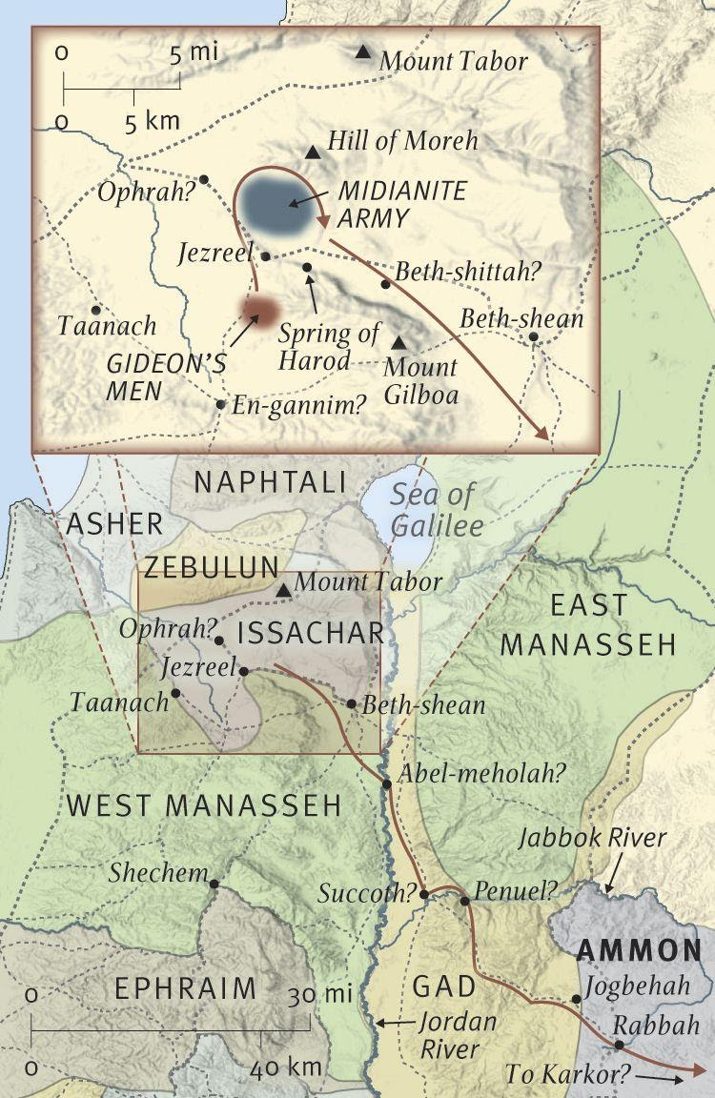
SLIDE: Once Gideon is firmly convinced that God has chosen him to lead Israel out of its oppression, he gathers the Israelite army — thirty-two thousand strong — at an encampment overlooking the valley where the Midianites are entrenched. BUILD: (See map). God whispers to Gideon, “That’s too many. Let any soldier who’s even the least bit fearful leave.” Twenty-two thousand soldiers depart, which isn’t exactly a rousing endorsement of Gideon’s leadership. But God tells him he still has too many and helps him sift through the rest of the troops until he has only three hundred dedicated warriors left (Judges 7:1-8).
BUILD: Why would God, then, put Gideon at such a disadvantage? God knows us well.
He knows that if the Israelites defeat the Midianites with their full army, they will become boastful and think their superior military strength and strategy saved them. Just as Adam and Eve thought they could be as wise as God, the Israelites might be tempted to believe they were as strong as God.
And like the Israelites, we still need to be humbled and reminded of this reality. BUILD: If the Israelites were to pull off an upset and defeat the Midianites with just three hundred men, they would know that their salvation comes from God, not from their own hands. Not only would THEY KNOW, but so would EVERYONE ELSE.
The Midianites knew there was no way Israel could defeat them. Gideon lays out God’s military strategy to his 300 courageous band of soldiers. Out of the 32,000 who originally joined, these are the ones who remained. Ever think that some may have doubted? Maybe I should have gotten down on my knees to drink? Ha! He tells his tiny army to light torches and then hide them inside jars of clay. Each soldier carries the clay pitcher in his left hand; in the other hand, following Gideon’s instructions, each carries a trumpet. They sneak up on the Midianite army at night, and at Gideon’s signal, they smash the pitchers and blow on their trumpets. Gideon has the soldiers shout in unison, “A sword for the LORD (Yahweh) and for Gideon!” (Judges 7:20). The flash fires and horn blowing confuse and frighten the Midianites so greatly that they run around it utter confusion. They must be thinking, If Israel has that many torchbearers and troubadours, just think how many soldiers they must have. They try to flee, but in the darkness they turn on each other with their swords. The battle is over before it started.
SLIDE: When the Midianites said, “No way,” Gideon had the men shout, “Yahweh.”
Gideon, the runt of the weakest family in the weakest tribe, leads a miniscule army of three hundred men to victory over the mighty Midianites. And under his leadership, Israel enjoys forty years of peace and prosperity.
BUILD: Unfortunately, after Gideon died, the Israelites fell back to their old ways: “No sooner had Gideon died than the Israelites again prostituted themselves to the Baals. They set up Baal-Berith as their god and did not remember the Lord their God, who had rescued them from the hands of all their enemies on every side.” (Judges 8:33-34)
You would think that after such a miraculous victory, the Israelites never would have wanted to do anything less than serve God faithfully forever. But they always ended up putting their own selfish interests ahead of God’s provision for them. BUILD: Instead of trusting that God knew what was best for them, they became resentful and concluded that following God’s ways would keep them from getting what they wanted. Instead of fulfilling their created purpose, they violated it, what the bible refers to as sin.
SLIDE: Three things are true of sin:
BUILD: Jer 2:13, “My people have committed two sins: They have forsaken me, the spring of living water, and have dug their own cisterns, broken cisterns that cannot hold water.”

- Sin will take you farther than you want to go
- Sin will keep you longer than you want to stay
- Sin will cost you more than you want to pay.

BUILD: Benefits of following Jesus…

Jesus will take you farther than you dreamed.
Jesus’ influence will transform you deeper than you thought possible.
Jesus will reward you beyond what you’ve invested.

BUILD: LET’S CHOOSE JESUS!
SLIDE: In Chapter 8:28, the text reads, “Thus Midian was subdued before the Israelites and did not raise its head again. During Gideon’s lifetime, the land had peace forty years.”

For some reason, in times of prosperity and abundance, we often grow distant or ignore God completely, feeling self-sufficient in our temporary happiness.
BUILD: Prov. 24:10, If you falter in times of trouble, how small is your strength! If you faint in the day of adversity. If you fail when times are hard.

BUILD: Scottish essayist Thomas Carlyle wrote: "Adversity is sometimes hard upon a man; but for one man who can stand prosperity, there are a hundred that will stand adversity."
Prosperity and abundance is a CHALLENGE.
Conversely, some of the most inspiring stories of devotion to God come from the poorest and most oppressed communities of faithful Christians.
Like the Israelites, we forget that the same God who saves us from our distress wants to walk with us and enjoy a relationship with us all the time, not just when our backs are against the wall. As we study the history of Christianity in the Western world, we see periods of spiritual lethargy — even rebellion against God — followed by great “awakenings” in which people cry out to Him and He answers with great power, reclaiming His children who have wandered from Him.
Our rebellion against God is always met with his invitation to return to Him. We can try it our way, until we get into such a mess that the only way to turn is toward God, and then He always takes us back. Our failures are NEVER final.
Here’s a good word from David Timms: "We gain nothing by beating ourselves up over failure. We gain everything by forging fresh resolve. The past moment does not have the same value as the present moment. What we have done or not done does not carry the same weight as what we choose to do right now. God lives in the perpetual present. He keeps less score than we do and is unfazed by our inconsistencies."

SLIDE: CORAM DEO - Living before the face of God
- BUILD: God was able to use the runt of the weakest family in the weakest tribe in Israel to rescue His nation from oppression. He will go to whatever lengths are necessary to reclaim His people so that we can experience what Jesus invited His original followers to experience. Here is His invitation,
“Are you tired? Worn out? Burned out on religion? Come to me. Get away with me and you’ll recover your life. I’ll show you how to take a real rest. Walk with me and work with me—watch how I do it. Learn the unforced rhythms of grace. I won’t lay anything heavy or ill-fitting on you. Keep company with me and you’ll learn to live freely and lightly.” – Matthew 11:29-30 (MSG).

- BUILD: As for those who are willing to do exactly what He wants them to do, God will use them like He used Gideon’s jars of clay, as vessels to pour out His blessings and to build His nation, even if they are cracked pots — small, insignificant, and overlooked by others!

“…We have this treasure in jars of clay to show that this all-surpassing power is from God and not from us.” - 2 Corinthians 4:7

