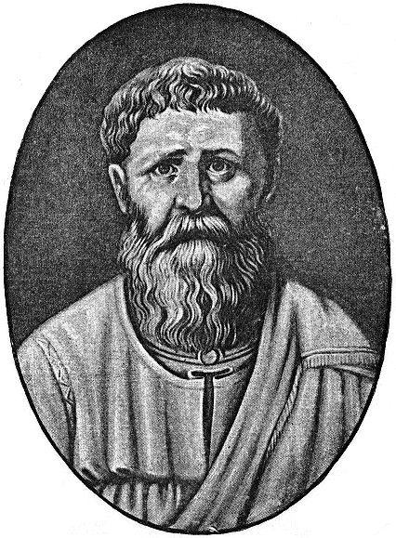Augustine 354 – 430
Accepted by most scholars to be the most important figure in the ancient Western church, St. Augustine was born in Tagaste, Numidia in North Africa. His mother was a Christian, but his father remained a pagan until late in life. After a rather unremarkable childhood, marred only by a case of stealing pears, Augustine drifted through several philosophical systems before converting to Christianity at the age of thirty-one. At the age of nineteen, however, Augustine had read a book by Cicero that led him into fascination with philosophical questions and methods that would remain with him throughout his life. Although tempted in the direction of Christianity upon his arrival at Milan in 383, he turned first to Neo-Platonism. During this time, Augustine fathered a child by a mistress. This period of exploration, including its youthful excesses (perhaps somewhat exaggerated) is recorded in Augustine’s most widely read work, the Confessions.
During his youth, Augustine had studied rhetoric at Carthage, a discipline that he used to gain employment teaching in Carthage and then in Rome and Milan, where he met Ambrose who is credited with effecting Augustine’s conversion and who baptized him in 387. Returning to his homeland soon after his conversion, he was ordained a presbyter in 391, taking the position as Bishop of Hippo in 396, a position which he held until his death in 430.

Besides the Confessions, Augustine’s most celebrated work is his (titled in English) The City of God, comprised of 22 books. It’s a study of the relationship between Christianity and secular society, which was inspired by the fall of Rome to the Visigoths in 410. Among many other works are included treatises titled On the Trinity; On Faith, Hope, and Love; On Christian Doctrine and On Free Choice of the Will, addressing why God gives humans free will that can be used for evil.

In his writings that had a great influence on Christian theology, he believed that the grace of God was indispensable to human freedom and he framed the concepts of original sin and just war. Augustine asserted that Christians should be pacifists as a personal, philosophical stance. Nonetheless, he asserted, peacefulness in the face of a grave wrong that could only be stopped by violence would be a sin. Defense of one’s self or others could be a necessity, especially when authorized by a legitimate authority. While not breaking down the conditions necessary for war to be just, Augustine nonetheless originated the very phrase, itself, in his work The City of God. In essence, the pursuit of peace must include the option of fighting to preserve it in the long-term. Such a war could not be pre-emptive, but defensive, to restore peace. Thomas Aquinas, centuries later, used the authority of Augustine’s arguments in an attempt to define the conditions under which a war could be termed just.
According to his contemporary, Jerome, Augustine “established anew the ancient Faith.” His thoughts profoundly influenced the ancient world. Many consider him to be one of the theological fathers of the Protestant Reformation due to his teachings on salvation and divine grace. St. Augustine stood as a powerful advocate for orthodoxy and can be seen to serve as a bridge between the ancient and medieval worlds. A review of his life and work shows him with an active mind engaging in the practical concerns of the churches he served.

