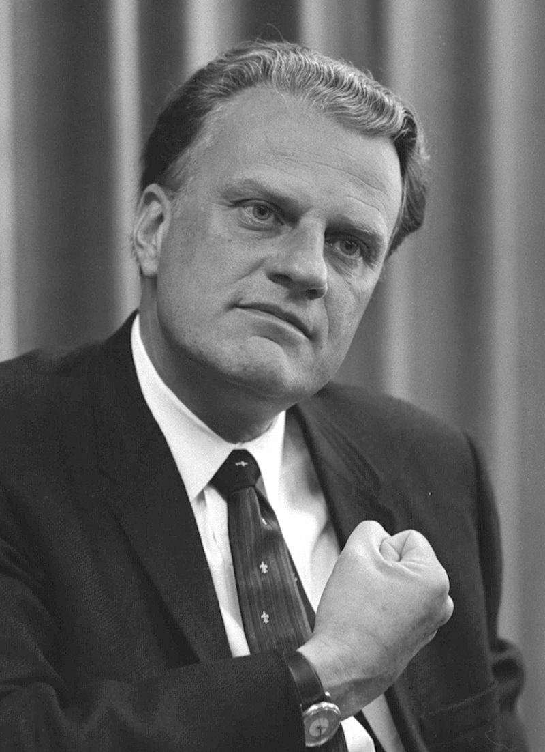 Billy Graham 1918 – 2018
Throughout his life, Billy Graham preached the gospel of Jesus Christ to some 215 million people who attended one of his more than 400 Crusades, simulcasts and evangelistic rallies in more than 185 countries and territories. He reached millions more through TV, video, film, the internet and 34 books. His memoir, Just As I Am (Harper Collins, 1997), remained on The New York Times best-seller list for 18 weeks.
Born Nov. 7, 1918, four days before the armistice ended World War I, William Franklin “Billy” Graham Jr. grew up during the Depression and developed a work ethic that would carry him through decades of ministry on six continents. Billy made his “commitment to Christ” at age 16 through the ministry of a traveling evangelist, Mordecai Ham. He was ordained as a Southern Baptist and pastored one congregation (First Baptist Church, Western Springs, Ill.), but the rest of his ministry was deliberately nondenominational.
He and Ruth McCue Bell, the daughter of medical missionaries in China, married in the summer of 1943. Mr. and Mrs. Graham and their five children made their home in the mountains of North Carolina. They were married for 64 years before Ruth’s death in 2007. Graham started the Billy Graham Evangelistic Association, which was incorporated in 1950. His ministry remained free of the financial and sexual scandals that marred the careers of other prominent contemporaries. Since 2000, Graham’s son, Franklin, has led the Charlotte-based organization, which employs some 500 people worldwide.
In 1996, Graham and his wife, Ruth, received the Congressional Gold Medal, the highest award Congress can bestow on a private citizen. He was also listed by Gallup as one of the “Ten Most Admired Men” 61 times—including 55 consecutive years (except 1976, when the question was not asked). Graham was cited by the George Washington Carver Memorial Institute for his contributions to race relations and by the Anti-Defamation League of the B’nai B’rith.
The litany of accomplishments is familiar. Billy Graham was the first Christian, eastern or western, to preach in public behind the Iron Curtain after World War II, culminating in giant gatherings in Budapest (1989) and Moscow (1992) and complemented by unprecedented invitations to North Korea (1992) and Beijing (1993). He was a friend to the Pope, the Queen, several Prime Ministers, and Presidents. When America needed a chaplain or pastor to help inaugurate or bury a President, or to bring comfort in times of terrible tragedy, it turned, more often than not, to Billy Graham.
While Graham’s primary focus was to take this message to the world, he also provided spiritual counsel to presidents, championed desegregation, and was a voice of hope and guidance in times of trial. In 2001, he comforted his country and the world when he spoke at the National Cathedral in Washington, following the Sept. 11 terrorist attacks. At three global conferences held in Amsterdam (1983, 1986, 2000), Graham gathered some 23,000 evangelists from 208 countries and territories to train them to carry the message of Jesus Christ around the world.
“I have one message: that Jesus Christ came, he died on a cross, he rose again, and he asked us to repent of our sins and receive him by faith as Lord and Savior, and if we do, we have forgiveness of all of our sins,” said Graham at his final Crusade in June 2005 at Flushing Meadows Corona Park in New York.
During the week of his 95th birthday in 2013, Graham delivered his final message via more than 480 television stations across the U.S. and Canada. More than 26,000 churches participated in this My Hope project, making it the Billy Graham Evangelistic Association’s largest evangelistic outreach ever in North America.
“There were a few times when I thought I was dying, and I saw my whole life come before me…” said Graham at his Cincinnati Crusade on June 24, 2002. “I didn’t say to the Lord, ‘I’m a preacher, and I’ve preached to many people.’ I said, ‘Oh Lord, I’m a sinner, and I still need Your forgiveness. I still need the cross.’ And I asked the Lord to give me peace in my heart, and He did—a wonderful peace that hasn’t left me.”
Age and Parkinson’s Disease may have taken their toll, but it did not quench Billy Graham’s spirit. “My mind tells me I ought to get out there and go,” he said, as he was beginning to feel the effects of his disease, “but I just can’t do it. But I’ll preach until there is no breath left in my body. I was called by God, and until God tells me to retire, I cannot. Whatever strength I have, whatever time God lets me have, is going to be dedicated to doing the work of an evangelist, as long as I live.” He died February 21, 1918 and is buried at the Billy Graham Library. Throughout his life, Graham was faithful to his calling, which is captured in the inscription placed on his grave marker: Preacher of the Gospel of the Lord Jesus Christ.

