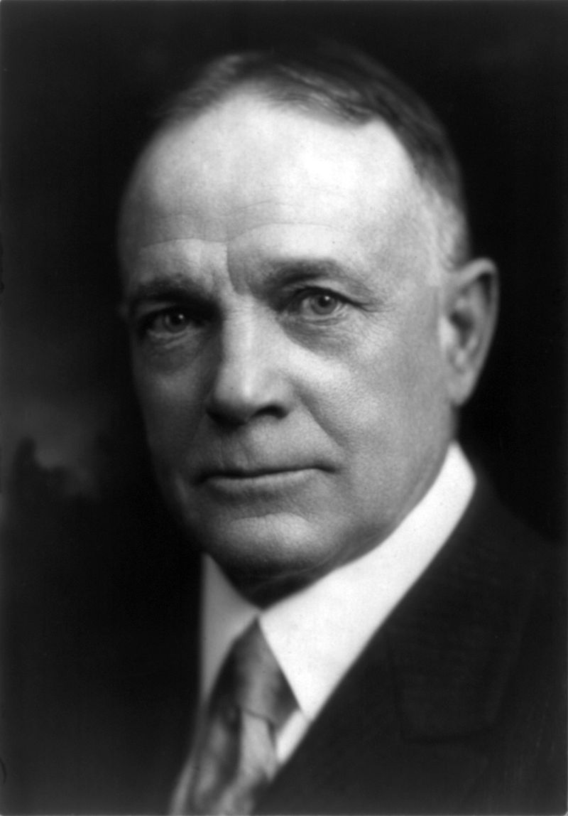 Billy Sunday 1862 – 1935

As the 1800’s turned into the 1900’s, Americans became more enamored with a revivalist whose name really was Billy Sunday, perhaps the most celebrated and influential American evangelist during the first two decades of the 20th century. Born into poverty in Iowa in 1862, his speed and agility provided him the opportunity to play baseball for eight years as a National league outfielder with the Chicago White-Stockings. Sunday had been converted at the Pacific Garden Mission in Chicago and was ordained by the Presbyterian Church in 1903. He was a conservative evangelical who accepted fundamentalist doctrines. He affirmed and preached the inerrancy of the Bible, the virgin birth of Christ, the doctrine of substitutionary atonement, the bodily resurrection of Christ, a literal devil and hell, and the imminent return of Jesus Christ. At the turn of the 20th century, most Protestant church members, regardless of denomination, gave assent to these doctrines. Sunday never attended seminary and made no pretense of being a theologian or an intellectual, but he had a thorough knowledge of the Bible, and was well read on religious and social issues of his day. His surviving library of six hundred books gives evidence of heavy use, including underscoring and reader’s notes in his characteristic all-caps printing.
When he became an evangelist, he attracted the largest crowds of any evangelist before the advent of electronic sound systems. Sunday’s homespun preaching had a wide appeal to his audiences, who were “entertained, reproached, exhorted, and astonished.” Sunday claimed to be “an old-fashioned preacher of the old-time religion,” and his uncomplicated sermons spoke of a personal God, salvation through Jesus Christ, and following the moral lessons of the Bible. He organized his staff like a business – with advance men, secretaries, managers, building supervisors, choristers, and local volunteers. He required that money for all his expenses be raised before he began a meeting in any city.
In 1908 Sunday was joined by Homer Rodeheaver, a great trombone player and song leader. People flocked to Sunday’s meetings. He had a talent for the dramatic, and his antics and rapid-fire delivery promised to be a good show. It was the age of vaudeville, and Sunday brought the trappings and theatrics of the stage to the tent meeting revivals. He had sawdust put on the floors of the “tabernacles” built for his meetings to muffle the noise of feet, and the “sawdust trail” became an expression referring to revival meetings.
Sunday’s altar call was painless, nothing like Jesus’ narrow gate. Sunday would ask, “Do you want God’s blessing on you, your home, your church, your nation, on New York? If you do, raise your hands . . . How many of you men and women will jump to your feet and come down and say, ‘Bill, here’s my hand for God, for home, for my native land, to live and conquer for Christ?’” Shaking Billy’s hand signified getting right with God. In spite of Sunday’s many converts (he claimed one million professions in over 300 revivals), it has been questioned how many actually became church members or were sure about the meaning of their conversion.
Sunday was welcomed into the circle of the social, economic, and political elite. He dined with numerous politicians, including Presidents Theodore Roosevelt and Woodrow Wilson, and counted both Herbert Hoover and John D. Rockefeller, Jr. as friends. Sunday was a strong supporter of Prohibition, and his preaching likely played a significant role in the adoption of the Eighteenth Amendment in 1919. His audiences grew smaller during the 1920s as Sunday grew older, religious revivals became less popular, and alternative sources of entertainment appeared. Nevertheless, Sunday continued to preach and remained a stalwart defender of conservative Christianity until his death in 1935. Before his death, Sunday estimated that he had preached nearly 20,000 sermons, an average of 42 per month from 1896 to 1935.

