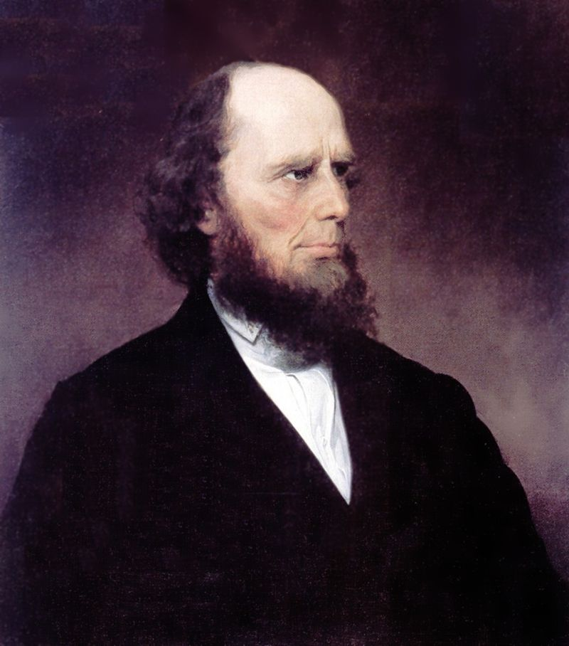 Charles G. Finney 1792 – 1875
During the first half of the 1800’s, the population of the United States grew from five to thirty million, and the boundary of the nation moved ever westward. Revivals became the primary means of Christianizing the growing and expanding population. These revivals became known as The Second Great Awakening. The most famous camp meeting held in 1801 by Barton W. Stone in Cane Ridge, Kentucky had some 23,000 people. The people were deeply affected by the simple preaching and strong emotional responses were considered proof of conversion. Revivals in the east, however, were much more subdued than those on the frontier.

The Second Great Awakening had a tremendous effect on American society by spawning a large number of social reform movements. A great encourager of such reforms was the evangelist Charles G. Finney. Finney, ordained in 1824, was to bring in new methods and new attitudes towards revival. Jonathan Edwards had viewed the 1735 revival (known as the Great Awakening) in Northampton as “a very extraordinary dispensation of Providence,” a “surprising work of God.” Charles Finney, however, believed that “a revival is not a miracle. . . It is a purely philosophic [i.e. scientific] result of the right use of the constituted means.”

In the series of revivals Finney held from 1824-1837 (during what some call the Third Awakening), Finney instituted a number of new measures which later evangelists would continue to use. These included the inquiry room for counseling seekers, the mourners’ bench for those responding to the public invitation to commit to Christ, preaching for an immediate decision, emotional prayers which addressed God in a very familiar, informal language, organized choirs and music, advertising and advanced preparation for the revival meetings.
Finney believed that revival was not something sent down by God, but it could be brought about if the right means were used. Man was free to choose his spiritual destiny, so Finney pressed for decisions. He was the first to have an “invitation,” calling people to the front to make a public witness of their conversion. He believed the gospel did not just get people saved, but it was also a means of cleaning up society. He and his followers worked to make the United States a Christian nation. In 1834, he moved into the huge Broadway Tabernacle his followers had built for him. He stayed there for only a year, leaving to pastor Oberlin Congregation Church and teach theology at Oberlin College. In 1851, he was appointed president, which gave him a new forum to advocate social reforms he championed, especially abolition of slavery.
The Second Great Awakening resulted in the establishment of numerous societies to aid in spreading the gospel including the American Bible Society (1816), the American Sunday School Union (1817), the American Tract Society (1826), and the American Home Missionary Society (1826). The Second Great Awakening had a greater effect on society than any other revival in America.

