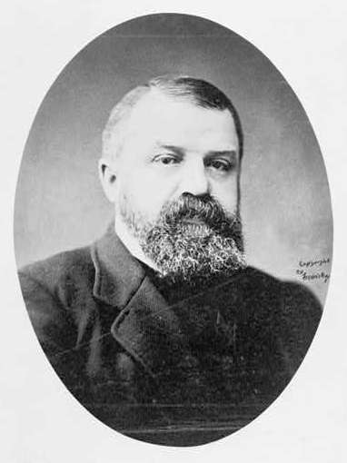 Dwight L. Moody 1837 – 1899
Undoubtedly the most prominent evangelist at the close of the 19th century was Dwight L. Moody. With only a fifth-grade education, he struck out on his own at age 17 and went to Boston to work in his uncle’s shoe shore. He lived at the YMCA and was converted at age 18. Shortly after that he moved to Chicago. Moody had a passion for seeing souls converted to Christ. Active in the 1859 prayer revival in Chicago, Moody helped establish Chicago’s YMCA and became its first full-time employee. In his eagerness to bring souls to Christ, Moody began preaching on the streets of Chicago. He packed his Sunday School with poor children he found roaming the streets, and he shocked many by even bringing slum dwellers to church.

The Great Chicago Fire in October 1871 destroyed Moody’s mission church, his home, and the YMCA. He traveled to New York to raise funds to rebuild the church and the YMCA, but while walking down Wall Street, he felt what he described as “a presence and power” as he had never known before. He returned to Chicago with a new vision: preaching the Kingdom of God, not social work, would change the world. He now devoted his immense energies solely to the “evangelization of the world in this generation.”

George Williams, founder of the YMCA, lived in London, and Moody traveled there on business. In the spring of 1872, he was asked to substitute preach in a London pulpit. When 400 people responded to his closing invitation, it seemed to be God’s direction to do even more evangelistic work. So, in 1873 Moody returned to England with his singing partner, Ira Sankey. What was planned as a small tour became a major two-year preaching tour throughout England, Scotland, and Ireland. Thousands packed churches and halls to hear the evangelists from America. Moody and Sankey returned home heroes and began a series of successful “preaching missions” in America.

As calls for crusades poured in, Moody pioneered many techniques of evangelism: a house-to-house canvass of residents prior to a crusade; an ecumenical approach enlisting cooperation from all local churches and evangelical lay leaders regardless of denominational affiliations; philanthropic support by the business community; the rental of a large, central building; the showcasing of a gospel soloist; and the use of an inquiry room for those wanting to repent. Even though Moody used some of the techniques Finney had in his revivals, Moody recognized that men were saved by the Spirit of God. Before his meetings he would often tell his Christian workers, “It is not our strength we want. It is not our work to make them believe. That is the work of the Spirit. Our work is to give them the Word of God. I cannot convert men; I can only proclaim the Gospel.”

Moody was not a sensationalist in his preaching. He spoke with a Yankee twang and often used poor grammar. In his gospel proclamation he always preached the Scriptures and what he called the three R’s – Ruined by sin; Redeemed by Christ; Regenerated by the Holy Spirit. His sermons were widely printed in the newspapers of his day and collected into books.

Finally, in 1886, Moody started the Bible-Work Institute of the Chicago Evangelization Society (renamed Moody Bible Institute shortly before his death in 1899). It was one of the first in the Bible school movement. From this work, he launched yet another work, the Colportage Association (later Moody Press), an organization using horse-drawn “Gospel wagons” from which students sold low-cost religious books and tracts throughout the nation.

