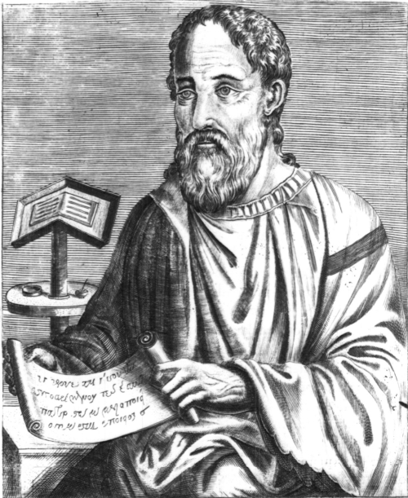 Eusebius 260 – 340

After the Book of Acts, the history of the church would have been lost had it not been for the efforts and scholarship of Eusebius. Origen had earlier recorded his theology and transliteration of the Scriptures, and Josephus’ Essential Writings recorded the Jewish history of the times. But it is Eusebius who is the most widely-consulted reference work on the early church. Much of our knowledge of the first three centuries of Christianity – the terrible persecutions, the courageous martyrs, and the theological controversies – comes from the writings of this first century historian.

He was born around the year 260 in the town in which he lived most of his life, Caesarea, the city on the Sea of Galilee, an important center of Greco-Roman learning and the administrative capital at Judea after the destruction of Jerusalem in 70 A.D. Caesarea had large groups of Jewish, Samaritan and Christian minorities, and Eusebius was born into a Christian family. He was baptized and schooled in respected centers of Christian learning. After Constantine became emperor of the Roman Empire in 312 A.D., Christians were free for the first time to pursue knowledge of the Scriptures without fear of persecution. Eusebius took full advantage of that freedom and used his scholarship skills to produce numerous works which have been preserved until today.

He traced the lines of apostolic succession in major cities where the first apostles had worked after Pentecost. He researched the lives of martyrs and incorporated their stories into his accounts. He traced the struggles of the Jews and maintained that their fate was the result of their rejection of Christ. He wrote commentaries on the Bible and also wrote about the early church’s heresies and challenges to the faith.

Eusebius was appointed a Bishop in Caesarea, became a friend of Emperor Constantine, and he played a prominent role at the Council of Nicaea in 325. After the Emperor's death, Eusebius wrote the Life of Constantine, an important historical work because of its eye witness accounts and the use of primary sources. Although many subsequent historians have dismissed Eusebius’ writings as unnecessarily flattering to the Emperor, his works are still considered important to the history of the early church.

