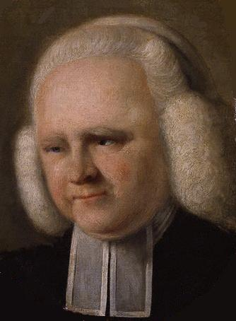 George Whitefield 1714 – 1770
Born in England in 1714, George Whitefield attended Oxford University and was ordained as an Anglican clergyman, but did not settle as the minister of any parish. Instead, he became an itinerant preacher and evangelist, and in 1737 began preaching in London and Bristol at a time when morality was at its lowest. In order to reach the many non-church goers, Whitefield often spoke in the open fields, and large crowds began gathering to hear the message of salvation. Whitefield went from place to place preaching as “one of God’s runabouts,” as he called himself, and travelling extensively in his wide-ranging ministry.

In his day, itinerant preachers were often criticized as interfering with or undermining the role of the parish priest. Whitefield countered that many of the established clergy could not bring life to their people since they themselves were spiritually dead. Whitefield’s preaching wasn’t different just because of his style; his message was different too. Where other Anglican ministers emphasized religious ritual or moral living, Whitefield preached conversion. His hearers must be inwardly changed through faith in Jesus Christ for a personal salvation from sin, to experience a new birth through the Holy Spirit. That conversion and regeneration could be experienced in an instant if only people would repent and believe.

Whitefield made seven trips to North America between 1738 and 1770. On his first trip in 1738 he traveled to the newly established colony of Georgia. There he conceived the idea of establishing an orphanage, which he named Bethesda. For the rest of his life, Whitefield raised money for the orphanage. He was probably the most well travelled man in the colonies and drew large crowds wherever he spoke. Widespread revival was most clearly seen during his second journey (1739-1741). As he toured the colonies, he would daily preach to large crowds in the open air because the churches were too small. The trip was well publicized, for Whitefield arranged for newspaper coverage and wrote many pamphlets and sermons on his journeys, thereby harnessing the power of the press for the sake of revival. Consequently, Whitefield preached to tremendously large crowds, including some gatherings that numbered in the tens of thousands.

Benjamin Franklin was fascinated with Whitefield’s speaking ability and the effects his teaching had on the people. Though Franklin never openly became a Christian himself, he did become a friend of Whitefield’s and also his publisher in America. He was impressed with the change Whitefield’s gospel preaching brought on society. Franklin wrote, “It was wonderful to see the change soon made in the manners of our inhabitants. From being thoughtless or indifferent about religion, it seemed as if all the world were growing religious, so that one could not walk through the town in an evening without hearing psalms sung in different families of every street.”
In 1748 Whitefield returned to England preaching multiple times each day. In 1769 he returned to the colonies for the final time and unsuccessfully pursued plans to found a college at Bethesda. Whitefield died in 1770 in Newburyport, Massachusetts, while on a preaching tour. His is buried in that town’s Presbyterian Church.

