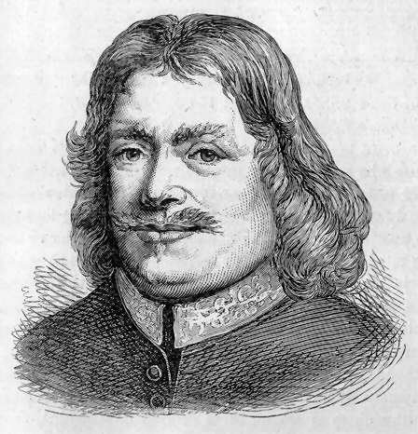 John Bunyan 1628 – 1688
John Bunyan, the author of Pilgrim’s Progress, was born to a poor family in England and had little formal education. His life reveals a gracious example of how God can mightily use one who repents and answers His call. In his younger days, he confessed, “It was my delight to be taken captive by the Devil.” He lived in an area of England where Puritanism was established and those who had lax behavior were often publically criticized. Despite his reputation as a filthy-mouthed ringleader, Bunyan admitted that his behavior did arouse feelings of guilt and shame. After a close call with death while serving in the military; he came to believe that God had a purpose for his life and began a different path on his journey.
After much soul searching, he read Luther’s commentary on Galatians and realized what faith in Christ really meant. He became an avid reader of the Bible and soon his friends noticed a great change taking place in his behavior. He gave up gambling, swearing and dancing, and began to reform his ways. He became a deacon in his church and a field preacher of such a powerful reputation that people would arrive at many hours ahead of time to listen to him.
British authorities feared that outdoor preachers would incite revolution during the times when people were challenging the rule of the monarchy, and Bunyan was arrested and sentenced to prison for preaching. To go free and return to his family, all he had to do was make one promise: agree not to preach publicly. His reply was this, “If I was out of prison today, I would preach the Gospel again tomorrow by the help of God.”
Bunyan had good company in his confinement; he and many other Christian prisoners had times of communal prayer and Bunyan preached to them whenever possible. His fellow-prisoners urged him to write down his messages for others to read. In and out of prison over twelve years, his writings reflected his physical and spiritual struggles. As he completed his story of Christian's journey to the Celestial City, Quaker friends worked for his release which was secured in 1677 soon after the first part of The Pilgrim's Progress was printed.
After his release from prison, Bunyan devoted himself to preaching, ministering and writing before he died of pneumonia in 1688. Although he wrote sixty books and preached extensively, he is best known as the author of Pilgrim’s Progress, the most widely circulated book to this day aside from the Bible.

