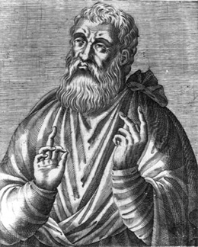 Justin Martyr c.100 – 165
Flavius Justinus was born in Samaria around 100 A.D., the son of noble Roman colonists. Greatly interested in philosophy, he studied the wisdom of Plato, Aristotle and other great Greek thinkers and became a professional philosopher until his conversion to Christianity about the year 130. He describes his conversion in his famous book, Dialogue with Trypho. One day, while reading philosophy by the seashore, he was noticed by an old man who took the time to strike up a conversation about philosophy and religion. The elderly gentleman was a Christian and witnessed to Justin on how Jesus fulfilled all the prophecies in the Jewish holy books. As Justin investigated the matter, he realized that he had found the wisdom that he had been searching for all of his life.
Justin became a Christian teacher and lived for a while in Ephesus, after which he moved to Rome, the Imperial Capital. Justin used his great knowledge to teach. He explained to the pagans why they should not worship idols and revealed to them the mysteries of the true Faith. He traveled to other lands to debate publicly. He also wrote two open letters, The First Apology and The Second Apology, to the emperor Antonius Pius and his son, the philosopher, Marcus Aurelius. In these long, written arguments known as apologies, he explained and defended the Faith. Though contemporary writers tell us that he wrote extensively on many topics, only his two apologies and his Dialogue with Trypo, the Jew, survive today.
At last Justin incurred the wrath of a cynic philosopher, Crescens, for criticizing his immorality, and Justin was arrested for being a Christian. He was brought before the Roman prefect, Junius Rusticus, to be accused. Just before Rusticus sentenced him to death, he asked Justin, “If you are killed, do you suppose you will go to heaven?” “I do not suppose it,” Justin answered, “but I know and am fully persuaded of it.” Justin and five other martyrs were beheaded around the year 165.
St. Justin is considered the most important of the second century apologists, and is an outstanding model for lay apostles of today. His life was devoted to the task of harmonizing the wisdom of the world with those greater riches revealed in the true Faith.

