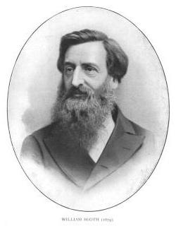 William Booth 1829 – 1912
William Booth, born in 1829 in Nottingham, England, was a zealous preacher and evangelist who, with his wife Catherine, founded the Salvation Army in 1865. William was a local preacher for the Wesleyan Methodists, but in 1861 he began independent evangelistic work in London. Thieves, prostitutes, gamblers, and drunkards were among Booth’s first converts to Christianity. His congregations were desperately poor, but he preached hope and salvation and a changed life. His aim was to lead them to Christ and link them to a church for continued spiritual guidance, but the local churches did not accept them. His converts did not fit the niche in the churches of London. So, he and his wife Catherine established the London Revival Society, and at their Christian Mission, he and Catherine housed, fed and gave practical and spiritual help to their constantly expanding flock.
William called himself the General Superintendent and as his volunteers spread throughout London and the neighboring cities, they became known as the Halleluiah Army. They went out to preach and sing in the streets as a living testimony to the power of God. His many famous words include these:

“I’ll fight while there is a drunkard left,
While there is a poor lost girl upon the streets,
While there remains one dark soul without the light of God,
I’ll fight – I’ll fight to the very end!”
Booth adopted military titles for the volunteers and developed strict standards of behavior by which they became identified. In twelve years, they had grown to 1,000 volunteers and 42 evangelists. They became known as the Salvation Army and soon spread to other countries
The Salvation Army expanded rapidly to Canada, Australia, France, Switzerland, India, South Africa, Iceland, Germany, and many other countries. In 1878, Lieutenant Eliza Shirley left England to bring the Salvation Army to the Philadelphia and to officially begin its work in the United States. In 1886, President Grover Cleveland received a delegation of Salvation Army officers and gave the organization a warm personal endorsement which has been followed by similar receptions from succeeding Presidents of the United States. William Booth died in 1912, but had laid a firm foundation for the Salvation Army which today is the most widely recognized relief organization serving people in 133 countries.

