Acts 2 – Power at Pentecost

Dan Leppo

Last week, Carol gave us a wonderful teaching on the first chapter which included Jesus’ final words to the church, His ascension, and the disciples deciding they should choose who the 12th disciple should be – not God. The disciples were gathered together in Jerusalem. The Nation of Israel observed seven primary feasts throughout the year. Three of them were more notable as they required all male Jewish men from all over the world to travel to Jerusalem to celebrate/observe the feasts. These three feasts were:

- The Feast of the Passover
- The Feast of Weeks
- The Feast of Tabernacles

As is so often the case with the Nation of Israel’s history, there are prophetic components to these events. In other words, there are New Testament fulfillments to each of these feasts. The Passover feast was celebrated each year on the fourteenth day of the Hebrew month, Nisan – which is either in March or April. This feast celebrated God’s deliverance of the Nation of Israel from the bondage of their slave-like conditions with Egypt. The New Testament fulfillment was Jesus’ crucifixion and resurrection. This glorious work of the Lord delivered all believing humanity from the bondage of its slavery to sin.

The Feast of Weeks was celebrated fifty days after the Feast of Firstfruits, which was observed two days after the Passover feast. The point of the Feast of weeks was to mark the first fruits of the wheat harvest. Another name for the Feast of weeks was Pentecost – “pente” denoting fifty. This is where we find ourselves at the beginning of chapter of two as we learn of the New Testament fulfillment for this feast.

Verse one makes an important point regarding setting the stage for what’s about to happen. They were all together in one place. When reading through the four gospel accounts, we didn’t find the disciples always on the same page. There was often a lack of unity. James and John wanted to sit on Jesus’ sides in His kingdom. Some of the disciples asked who would be the greatest among them. Then there was Judas. However, here we see the guys are in one place and in one accord. Some Bible scholars have speculated the disciples were in the same upper room as where the Last Supper was held, but we really don’t know for sure.

Out of nowhere a sound of a loud, blowing wind came from heaven and filled the room. Visible tongues of fire came to rest on each of the disciples. This newfound power enabled them to speak in languages that were not their own. Apparently, the noise from the wind was so loud that it was heard by many people outside. Many of these people were from other parts of the world to celebrate Pentecost. When trying to find out where the noise was, they started hearing the different languages, or tongues, that the disciples were speaking. They recognized that these languages were from their countries. They’re “blown away” by the fact that these simple Galilean men are speaking in languages from all over the region.

Below is a map to give you an idea of how widespread these languages were coming from:

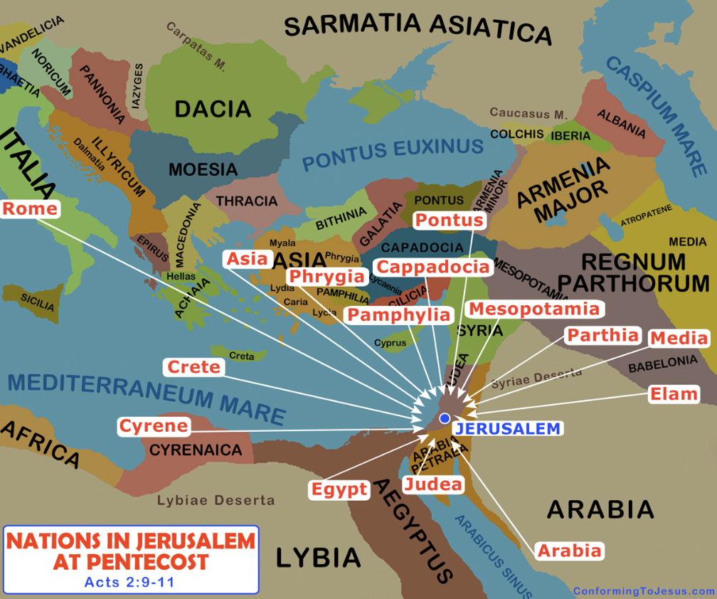

Verse 11 provides very important detail regarding tongues – the emphasis on these utterances were on the wonders of God – likely praising God. The topic of speaking in tongues is a controversial topic with some parts of the church. Some denominations don’t believe they exist any longer. Other components – typically the Pentecostal and Charismatic churches – believe not only believe they do still exist, but also, they promote the use of them on a regular basis.

There is nothing in the Bible that states that tongues were restricted only for the apostles, or that when they died, so did that gift. However, tongues are a sovereign gift from God given to some people for the primary purpose of a private prayer language between God and the believer. They are not a measuring stick of one’s faith. Tongues should never be spoken out loud without them being accompanied with the provision of interpretation. That is Biblical.

The real takeaway from this scene is we have a third movement of the Holy Spirit. We have a trinity of prepositions. Prior to this moment, the Bible spoke of the Spirit being with someone. This is where the Holy Spirit is coming alongside someone doing His sin-convicting work. The second movement of the Spirit is He is placed in someone. This is the giving of the indwelling of the Holy Spirit to each person who declares Jesus Christ to be his/her Lord & Savior. With this event, we have the Spirit coming upon people for the purpose of empowerment.

For the people who didn’t understand the languages the apostles were speaking, they concluded the guys were drunk. Peter then arises to provide the first sermon to the church. He claims that he and the apostles couldn’t be drunk – it was only 9:00 in the morning. Clearly, Peter did not go to the college I attended! That time in the morning was known as “Beer-a-clock!”

The question Peter is now going to answer is a great question for both the believer and non-believer, “What does this mean?” Before I get into his sermon, I think it’s important that we consider who is giving this response. Less than two months ago, big, tough, and impetuous Peter cowered under the questioning of a little girl who claimed he knew and followed Jesus. This was the fulfillment of the Lord’s prophecy that Peter would deny Him three times in one night.

While I have no doubt Peter loved the Lord and believed in Him with all his heart, he relied too heavily on his self-confidence. So, what has happened to bring Peter from his terrible failure to now standing up and giving an extraordinary presentation reciting multiple Old Testament Scriptures? I propose three things:

- From his failure, he was humbled. His self-confidence was obliterated.
- He saw, spoke to, and was restored by the risen Jesus.
- He received power from the Holy Spirit.

For us today, the path to becoming the person whom God designed and empowers for service begins with humility. Let’s take a look at a few verses that speak the value God places on humility:

Philippians 2:3: “Do nothing out of selfish ambition or vain conceit. Rather, in humility value others above yourselves.”

Micah 6:8: “He has shown you, O mortal, what is good. And what does the Lord require of you? To act justly and to love mercy and to walk humbly with your God.”

1 Peter 5:6: “Humble yourselves, therefore, under God’s mighty hand, that he may lift you up in due time.

If we are allowing our pride or self-righteousness to drive us to control everything and demand our way, we are preventing the Holy Spirit to flex His far greater power, wisdom, and ways. When we walk in humility, we are walking away from pride. C.S. Lewis appropriately called pride “the great sin.” Peter’s pride was crushed from his failure, so he was now available to allow the Holy Spirit’s far greater power to equip him with a remarkable sermon.

Peter quotes from Joel 2:28-32a. This is the answer to, “What does this mean?” This is the beginning of the church that welcomes all who believe. With Jesus now at the right hand of the Father, being the Good Shepherd that He is, He knew that we sheep needed ongoing help. Perhaps the better question than “What does this mean?” is “Who is this?” The Who is the Holy Spirit – a co-equal member of the triune Godhead.

From John chapter 14, verses 16-17 and 26, Jesus provides us details on who the Holy Spirit is and what His responsibilities are: “And I will pray the Father, and He will give you another Helper, that He may abide with you forever— the Spirit of truth, whom the world cannot receive, because it neither sees Him nor knows Him; but you know Him, for He dwells with you and will be in you. But the Helper, the Holy Spirit, whom the Father will send in My name, He will teach you all things and bring to your remembrance all things that I said to you.”

Let’s break out this beautiful introduction – kind of like a resume and/or job description of the Holy Spirit.

- He is a gift from God the Father.
- He is our Helper. The Greek word is “parakletos,” which also means comforter.
- He will abide forever – confirming we will never be left nor forsaken.
- He is the truth. In a world saturated with lies, unfettered access to the truth is essential for survival.
- While He is a gift from the Father, He is only a gift to those who choose to believe in the Father’s Son, Jesus. Without faith, the Holy Spirit is a complete enigma or mystery.
- He is knowable. While the Holy Spirit, at least for me, is the most difficult of the three members of Holy Trinity to comprehend, He is every bit the living Being that we can communicate with.
- A big part of His communication takes the form of being a teacher. Again, for me, I would add interpreter. Let’s face it, sometimes God’s Word or spiritual things are hard to understand – like a foreign language we don’t know. The Holy Spirit, if we ask Him, will help us learn the complicated.
- Finally, He will help us remember the Word of God. With our enemy relentlessly hurling lies our way, we need to stand on and draw from our memory of the Word of God to keep us from temptation or unbelief.

I’m going to add one more thing regarding the Holy Spirit from the Apostle Paul from Ephesians 1:13b-14, “you were sealed with the Holy Spirit of promise, who is the guarantee of our inheritance until the redemption of the purchased possession.” Paul informs us that the Holy Spirit is the down payment for each believer’s redemption. He is the assurance that regardless of your failures or trials of suffering you’re experiencing, your salvation by faith in Jesus Christ is unshakable and unbreakable.

Peter plainly lays out the facts of Jesus’ ministry, His death, and His resurrection in verse 22-24. They witnessed the testimonies of Jesus being the Son of the good and loving God – His miracles, wonders, and signs. Verse 23 is a vital truth that too much of the church and its history has ignored. The Jews did not have Jesus killed. Listen to these words, “This man was handed over to you by God’s deliberate plan and foreknowledge.”

It was God the Father’s will for His Son to be killed. Just take that in for a moment. This is where a deep knowledge of the character of God is so essential. For the nonbeliever, you can imagine how this truth can be a reason to reject the God in Whom we choose to believe. In the shadow of this difficult truth of the Father’s will, we must confirm in our hearts His motivation. This holy God created, in His image, a holy and good human being. He created humanity for the purpose to love and enjoy His blessings as well as glorify Him in how we live. However, when His creation rejected the one thing He said we couldn’t have, that rejection, or sin, separated us from Him.

Not only coming from a place of holiness, but also coming from a place of passionate love, mercy, and forgiveness for what He created, He chose to make a way for His creation to be reconciled to Him. That being said, He needed to send a message of the seriousness of sin and its deadly consequences of living not just this life but eternal life void of that reconcilement. What could be a more vivid example of the seriousness of sin to a holy God than being the only way to accomplish this reconcilement was for His only begotten Son to:

- Have to leave His Father’s side in heaven;
- Humble Himself into becoming a human being;
- Live a sinless life;
- Perform never-seen-before miracles of goodness and love; and,
- Become a sacrifice for our sins via being wrongfully accused, tortured, and crucified.

You want to know who sent Jesus to the cross? I did. Each of you did. Despite our sin, God still loved us enough to send His Son to make a way for us to be reconciled to Him. If that wasn’t enough, this reconciling mechanism of grace need only be confirmed with a proclamation of faith in this truth. Can I get an amen?!

Peter continues to pull from the Old Testament. Verses 25-28 are direct quotes from King Davids’ Psalm 16:8-11b. Again, let’s break out these amazing promises of truth:

- The Lord is always before us – He is at our right hand. We don’t need to be shaken;
- With this truth, we can be glad, rejoice, and rest in hope;
- He will not abandon us in death;
- He makes known our path of life; and,
- He fills us with joy in His presence.

Regarding the portion of verse 27 that says, “you will not let your holy one see decay,” this is a prophecy of Jesus’ resurrection. Specifically, David is speaking to what Jesus did after He was laid to rest in His tomb. The Lord said in Matthew 12:40, “For as Jonah was three days and three nights in the belly of a huge fish, so the Son of Man will be three days and three nights in the heart of the earth.” What would Jesus be doing in the heart of the earth? From 1 Peter 3:18b-19, “He was put to death in the body but made alive in the Spirit. After being made alive, he went and made proclamation to the imprisoned spirits.” The risen Jesus went to deliver the good news of His victory at the cross to those believers who were being held at Abraham’s bosom from the Old Testament.

Peter continues with the word “confidently” in his sermon. How did he arrive at this confidence? Well, it helps to walk with Jesus Himself for three straight years – that’s a bonus. However, that wasn’t enough to help him stand up to a little girl’s claim that he was a follower of Jesus. The confidence that Peter had is the same confidence that Carol, Maggie, me and the rest of the lectures have. That confidence is the Holy Spirit’s confirmation of the truth of the Word of God and His empowerment for us to teach and proclaim it.

Peter confirms that King David died and was buried. Apparently, at the time of Acts, they knew where David was buried. Peter confirms that David was not only a king, but also a prophet. He quotes in verse 30 Psalm 132:11, “The Lord swore an oath to David, a sure oath he will not revoke: “One of your own descendants I will place on your throne.” We know from the genealogies of Jesus from both Matthew and Luke that David was indeed in the line of Jesus.

Peter, speaking for all the disciples, confirms that they witnessed the risen Jesus. As I mentioned earlier, one of the things that transformed Peter from the impetuous and over-confident man that he was to what we’re hearing now is his personal witness to the risen Lord. All but John experienced violent deaths for their faith in Christ. According to tradition, John was boiled in oil, but he survived this.

There are many proofs of Jesus’ resurrection, but, at least for me, how the disciples went from sometimes being the equivalent of the Keystone Cops before the Lord’s death and resurrection to what they became after it is the greatest proof. Think about this, if they did not see the risen Jesus, wouldn’t you imagine at least one of them would have denied their faith in the face of a violent death? Seeing the risen Jesus coupled with the indwelling of the Holy Spirt gave them that confidence.

Peter concludes with the truth that this risen Jesus is now exalted at the right hand of God. He finished his redemptive work, and as part of His reward for this finished work, the Father gave Him the Holy Spirit to pour out on all believers. This is the inauguration of the church age.

Peter wraps up his sermon with the plain truth that, “God has made this Jesus, whom you crucified, both Lord and Messiah.” I would imagine many of you have heard the saying, “The truth hurts.” I have an addendum to this saying, “The truth only hurts if you’re not living in the truth.” Verse 37 confirms that his presentation of the truth broke through the lies many people were believing, and it hurt – it cut to their hearts. From this place of conviction, they ask the question we can only hope every person will one day ask us, “What shall we do?”

Peter’s response was repent and be baptized in the name of Jesus Christ for the forgiveness of sins. For those who are proponents that baptism is a necessary component of salvation, they will quote this verse. In Mark 16:16 where we hear Jesus Himself say, “He who believes and is baptized will be saved; but he who does not believe will be condemned.” Again, in reading the first half of this verse, it does sound like baptism is a component of salvation.

However, please pay attention to the second half of the verse. “But he who does not believe will be condemned.” The condemnation does not come from the absence of baptism. The condemnation only comes from the absence of belief or faith. Romans 10:9 confirms that salvation is by faith alone, “if you confess with your mouth the Lord Jesus and believe in your heart that God has raised Him from the dead, you will be saved.” I don’t hear the word baptism in Romans 10:9, do you?

Peter then closes his sermon with a pleading, “Save yourselves from this corrupt generation.” Can you hear the voice of Jesus in this pleading? Given all that He went through to make salvation available, wouldn’t you think He would want as many people as possible to take advantage of His efforts? This is the love of God at work. Peter’s message reached about 3,000 people’s hearts, and the church of Jesus Christ began.

We then are given the four pillars of what His church should always have:

- Devotion to the apostles’ teaching. This is the teaching of the Word of God.
- Fellowship – the church body should be regularly meeting – not just on Sundays. Small/life/growth groups have their place, but for the purpose of corporate fellowship/blessings, the entire body of the church should be getting together.
- Breaking of bread. During Bible times, the breaking of bread was symbolic of unity – being together as one.
- Prayer. Colossians 1:18 confirms Jesus is the head of the church. If Jesus is the head of the church, then prayer must be a central component of a church as it is the form of communication to learn from Jesus, seek guidance from Jesus, and seek help from Jesus.

The church set-up a quasi-communistic economic system where everyone sold their belongings, gave it to the church, and the church would take the money and give it to anyone in need.

Hmmm…what am I not seeing on this list? Church building/fundraising programs; expensive and extravagant alleged worship programs that are really designed to entertain – not glorify God; carnal-driven gimmicks to attract the unchurched. The lie behind all of these efforts is if you’re going to use carnal methods to attract people, you’re going to have to keep using them to keep the people in the seats. I don’t believe any of this is necessary.

I can hear some of you already, “Dan, you don’t understand. Times have changed. You have to use these methods to get people to come.” Yes, times have changed, but God has not. A church where Jesus is the head – not some overpaid CEO of a pastor, is a church that is to be a spiritual hospital. It’s to be a place to be equipped to respond to those who are in real spiritual need – people who are truly seeking God. It’s to be a place where the Holy Spirit is free to empower, teach, and minister to people who are hurting.

If growth-obsessed, self-righteous church leaders are driving the decisions, I believe this is squelching the Holy Spirit. I also believe it is not the job of a church to add people. Listen to Who is doing the work of adding to the church in the final verse of chapter 2, “And the Lord added to their number daily those who were being saved.” I believe with all my heart that the Lord will direct people to a church that remains faithful to these four pillars. Ok, soapbox time is over.

I began this lecture talking about the three main Jewish feasts, and they were symbolic of the church’s history. The Passover’s New Testament fulfillment was Jesus’ crucifixion and resurrection. The Feast of Weeks, or Pentecost, was fulfilled with the coming of the Holy Spirit and the beginning of the church. What about the final feast, the Feast of Tabernacles? As opposed to the first two feasts which occurred in the Spring, this feast happens in the Fall. Its purpose is to celebrate the conclusion of the harvest. This feast’s New Testament fulfillment has not yet been realized.

I believe that harvest-concluding fulfillment will be Jesus’ second coming. The church will have been raptured, and at the end of the 7-year tribulation, the Jews will be reconciled to the Lord. The harvest will be complete. Given the fulfillment of the first two feasts occurred in the Spring, I believe it makes sense that the fulfillment for the Fall-time Feast of Tabernacles – Jesus’ second coming - will happen then. This is me speculating. Jesus Himself said we don’t know when He will return. But I see a pattern of fulfillments established. If Jesus’ second coming happens in the Fall, and the Tribulation period is seven years long, then I believe it’s quite possible that the Rapture will happen in the Fall. What time of season are we in now??? I don’t know about you, but I’m ready for a twinkling of an Eye. Kind of fun to think about, huh?

What should we do until then? Study the Word, keep meeting together; focus on being united through the breaking of bread; and prayer. Amen? Let’s stand and sing.

