It Is God Who Gives the Victory
(2 Samuel 20:3-21:14; 22:1-51)

Many of you know here at Eastside, our leadership team spends 2.5 days every six months to seek God’s direction for the next six months of ministry. The outcome is then shared with the greater ministry team where alignment occurs and strategies are considered in order to meet the goals. Those goals and strategies are then shared with the entire staff.

The theme verse for this Strategic Planning Process is SLIDE: Proverbs 21:31, The horse is made ready for the day of battle, but victory rests with the Lord.

The proverb reminds us of Moses’ plea to the Lord, SLIDE: “You have been telling me, ‘Lead these people,’ but you have not let me know whom you will send with me. You have said, ‘I know you by name and you have found favor with me.’ If you are pleased with me, teach me your ways so I may know you and continue to find favor with you. Remember that this nation is your people.” The LORD replied, “My Presence will go with you, and I will give you rest.” Then Moses said to him, “If your Presence does not go with us, do not send us up from here. How will anyone know that you are pleased with me and with your people unless you go with us? What else will distinguish me and your people from all the other people on the face of the earth?” - Ex. 33:12-16

David certainly echoed these sentiments in his song of praise. But prior to arriving at chapter 22, let’s take a quick look at the two preceding chapters.

SLIDE: David's Sin and Its Consequences – 20:3

Spanish proverb, “He who have loved one woman has loved them all, he who have loved many has loved none.” There is a deep beauty in being a one woman man.

BUILD: Sin has a ripple effect, does it not? You never ever sin alone. When you sin, you are changed. You are marred in some way. The image of God stamped upon you is distorted. When you are changed, you will change others. Biblically speaking, there is no such thing as a victimless crime.

Here we have 10 more victims.

Before his flight from Jerusalem in the wake of Absalom’s conspiracy, David had “left” ten concubines to “take care of” the palace (15:16). Ahithophel (A-hith-O-Fel), Bathsheba’s grandfather counsels Absalom to “lie with your father’s concubines…so they pitched a tent for Absalom on the roof, and he lay with his father’s concubines in the sight of all Israel (16:21-22). Don’t miss the irony and the lingering consequences of sin. Where did David first see Bathsheba? On a rooftop. Where does Bathsheba’s grandfather, and David’s former Secretary of State counsel he commit this act? On a rooftop! Who paid the price? The 10 concubines. A victimless crime?

Returning now to his “palace,” David takes the concubines who were to care for the “palace” and puts them in a “house” under guard, virtually incarcerating them. Although he “returned” to the palace, David did not “lie” with the concubines. To be sure, David makes certain that the concubines’ needs are “provided” for, but he also keeps them in confinement under house arrest, and they are forced to remain in that situation—as though “widows”—for the rest of their lives (v.3).

The Rebellion of Sheba (20:4-25)
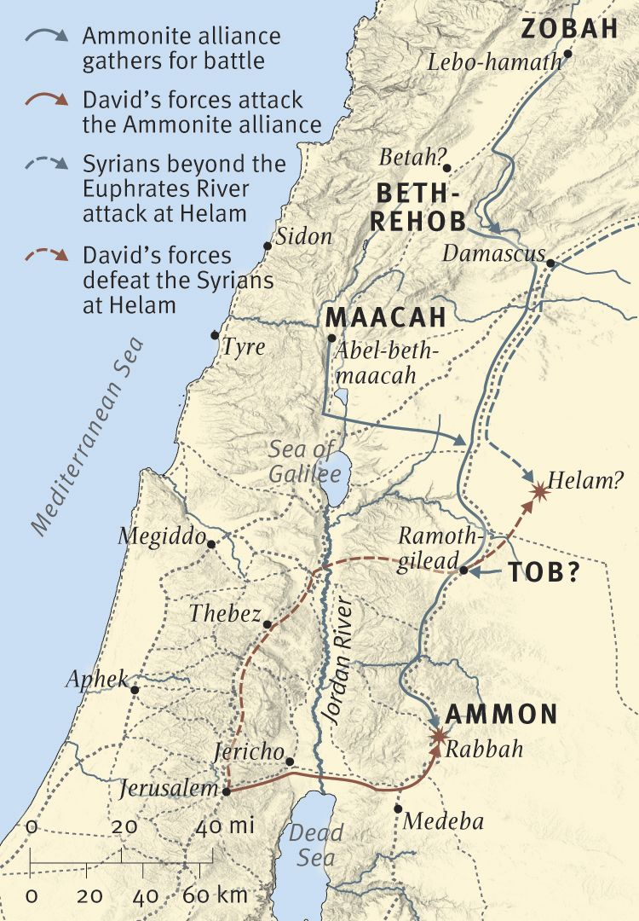
Sounding a ram’s-horn trumpet, Sheba delivers a brief but powerful statement (v.1) that would become a rallying cry for future secessionists. He declares that he and his compatriots have no “share” in David’s realm and no “part” in “Jesse’s son.”

Joab pursues Sheba some 80 miles to the north (see map) to Abel Beth Maacah and lays siege to the city.

Camp writes, “And so the rebellion of Sheba son of Bicri comes to an inglorious end. With a surgical strike against one man rather than by destroying an entire city, the populace is spared all because of the calming advice of the wise woman of Abel. “Sagacity, faithfulness, a commanding presence, and readily acknowledged influence with her peers—these are the attributes that clearly mark this woman”.

She appealed the better angels of Joab’s nature.

The Lord’s Wrath Against Israel (21:1-14)

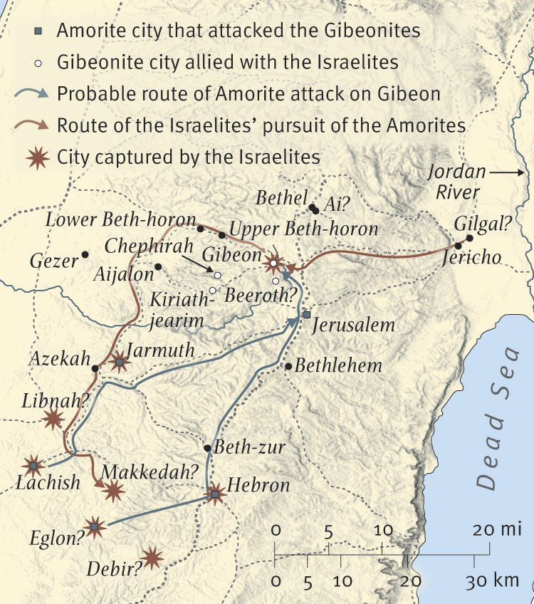
The account of the Gibeonites’ revenge (vv.1-14) begins with the Lord’s wrath against Israel as expressed in a three-year famine (v.1) and ends with the Lord’s answer to Israel’s prayers by removing it (v.14).

- David’s request (vv.1-4),
- Gibeon’s demand (vv.5-6),
- David’s acquiescence (vv.7-9),
- Rizpah’s vigil (v.10), and
- David’s final act of respect to the house of Saul… (vv.11-14)

…Constitute the various segments of the episode.

Background: Saul’s crime is that he had “put the Gibeonites to death” (for the location of Gibeon, see map) and in so doing had violated the age-old “treaty with the Gibeonites” made with them by Joshua (Josh 9:16), one of the provisions of which was that the Israelites would “let them live” (Josh 9:15, 20-21). Despite the fact that Israel’s people “did not kill them” (Josh 9:26), Israel’s first king “put [some of them] to death” (21:1).

If you recall, the Gibeonite treaty was predicated upon a ruse. They pretended they were from a distant land and thus the Israelites made a treaty with them. “The men of Israel sampled their provisions but did not inquire of the LORD,Then Joshua made a treaty of peace with them to let them live, and the leaders of the assembly ratified it by oath” – Josh. 9:14-15. “…We will let them live, so that wrath will not fall on us for breaking the oath we swore to them” (9:20).

The Gideonites request seven sons of Saul as symbolic of full retribution for covenant violation. Note verse 7, “The king spared Mephibosheth son of Jonathan, the son of Saul, because of the oath before the LORD between David and Jonathan son of Saul.” And soat Gibeah (3 miles north of Jerusalem and Saul’s hometown – 1 Sam. 10:10), the sons are killed and “exposed”. Polzin comments, “The Hebrew verb exposed designates “a solemn ritual act of execution imposed for breach of covenant,” probably involving the “cutting up or dismembering of a treaty violator as a punishment for treaty violation”. See Gen. 15:17-18a, When the sun had set and darkness had fallen, a smoking firepot with a blazing torch appeared and passed between the pieces. On that day the LORD made a covenant with Abram.

Notes Covenant Making: The act of dividing the animals and walking through the parts was apparently an ancient form of contractual agreement. Very little is actually known of this custom from records of the ancient world, though commentators have frequently pointed to some possible parallels. One notable is Jeremiah 34:18—“The men who have violated my covenant and have not fulfilled the terms of the covenant they made before me, I will treat like the calf they cut in two and then walked between its pieces.

The smoking firepot with a blazing torch symbolized the presence of God (see Ex 3:2; 14:24; 19:18; 1Ki 18:38; Ac 2:3-4).

SLIDE: COVENANT VIOLATION HAS IT CONSEQUENCES AND IT’S PRICE.

BUILD: Jeremiah 34:18—“The men who have violated my covenant and have not fulfilled the terms of the covenant they made before me, I will treat like the calf they cut in two and then walked between its pieces.

BUILD: Hebrews 7:27; 9:12; 10:10, “He sacrificed for their sins once for all when he offered himself…He did not enter by means of the blood of goats and calves; but he entered the Most Holy Place once for all by his own blood, having obtained eternal redemption…we have been made holy through the sacrifice of the body of Jesus Christ once for all.”

In response to this Paul asks in the Roman letter, “Do you show contempt for the riches of his kindness, tolerance and patience, not realizing that God’s kindness leads you toward repentance?” (2:4).

SLIDE: Glory to God Alone – 2 Samuel 22

The final sola of The Five Solas of the Reformation is…

- sola fide,
- sola gratia,
- solus Christus,
- sola Scriptura, and
- soli Deo gloria.

Justification is the act of God by which He declares sinners to be righteous by grace alone through faith alone because of Christ alone.

The prophet ISAIAH wrote, 42:8 "I am the LORD; that is my name; my glory I give to no other, nor my praise to carved idols."

The Westminster Shorter Catechism tells us that "man's chief end is to glorify God, and to enjoy him forever." God's glory is the highest good and therefore is the purpose for which we were created. We were made to glorify Him, to reflect His glory and proclaim it to all creation (Isa. 43:6-7). In saving His people and defeating their enemies, David paid tribute to His glory. Salvation must be through faith alone, by grace alone, and on account of Christ alone — because to attribute redemption to our efforts in any way is to rob God of His full glory.

We must take seriously the teaching in Romans 1:18-32 that the basic sin of humanity is its refusal to honor God as God and thank Him for all that He has given us. Instead of bowing the knee to the Almighty, we suppress knowledge of Him and make all sorts of lesser gods. If we look at our culture, It will try to convince us that stolen waters are sweet.

In the words of Jeremiah (2:13), we commit two sins:

- We forsake God, the spring of living water, and
- We did our own cisterns, however they’re broken and cannot hold water.

Any time we substitute something else for the God of the Bible, we attempt to have Him share His glory with another. Any time we deny one of His attributes, we conceive of Him as less than the sovereign Lord of all.

In a chapter entitled, The Peculiar Perils of Leadership, Oswald Sanders (Spiritual Leadership - page 231) quotes Charles Spurgeon about the unique dangers of popularity and success in ministry,

Success exposes a man to the pressure of people and thus tempts him to hold on to his gains by means of fleshly methods and practices, and to let himself be ruled wholly by the dictatorial demands of incessant expansion. Success can go to my head, and will unless I remember that it is God who accomplishes the work, that He can continue to do so without my help, and that He will be able to make out with other means whenever He cuts me down to size.

To counter that, I appreciate what Haley Morgan wrote in a piece for She Reads Truth,

And Haman said to the king, “For the man whom the king delights to honor, let royal robes be brought, which the king has worn, and the horse that the king has ridden, and on whose head a royal crown is set.” -Esther 6:7,8

The Kingdom of God is upside down in the wildest ways. It’s absolutely counter-cultural and tips the scales of reason even today, more than 2000 years after Jesus walked the Earth. In God’s kingdom, the oppressed are liberated, the mighty are brought low, and the orphan is set in a family. Leaders lead best when they are humble, and Scripture tells us God opposes the proud (James 4:6).

Oftentimes, I want a bright and shiny appointment from the King. I want to be out in front, up on stage, under the lights. Sure, I want to please the Lord, but if I’m honest I also want the earthly trappings that come from leading. But, as John the Baptist understood, Christ must always increase and I must always decrease if I am to be in line with His standards of humility (John 3:30).

Haman looked to the king and wanted desperately, in all of his pride, to be cloaked like a king himself. He wanted to be like the king. So when Mordecai received the honors Haman felt like he himself deserved, it was as if someone else had been chosen as the lead in the school play! Haman is humiliated. He’s angry. He sees no point in serving the king if it doesn’t also bring glory to himself.

How often are we tempted to believe the same thing—that we are not seen by God unless we are wearing the robes of Doing Big Things or Being Important? Sometimes we want to be recognized as valuable to God in the eyes of others more than we want to be seen by God Himself.

We must be made less and God must be made more. Yet in His immense goodness, God promises that we will share in a Heavenly eternity with Him. He has forgiven us of much, and loves us much more. In God’s perfect, upside-down way, it isn’t standing tall and getting it right that makes things better or makes us important. We are forgiven when we see our sin, bow low in acknowledgement, and turn away from our old ways. It is with God that we are humbled but not humiliated, brought low but not crushed.

SLIDE: CORAM DEO - Living before the face of God

I am praying for them. I am not praying for people in the world but for those you gave me, because they are yours. All I have is yours, and all you have is mine. And my glory is shown through them - John 17:9-10 (NCV)

"Glory" is one of the most common words in Scripture in the Old Testament. The Hebrew word kabod (K-B-D) originally means "weight" or "heaviness." The same word is then used to express importance, honor, and majesty. Greek versions of the Hebrew Bible translated this concept with the word doxa, which was then used extensively in the New Testament as well. Doxa originally means "judgment, opinion", and by extension, "good reputation, honor".

Since we are created in the Image of God, human beings can share or participate in divine glory as image-bearers. Like a mirror, we reflect God's glory, we make the invisible God visible to a watching world. Thus as Christians we are instructed to "let our light shine before men, that they may see your good works, and glorify your Father who is in heaven"- Matt. 5:16).

BUILD: C.S. Lewis in “The Weight of Glory” wrote, “it is a serious thing to live in a society of possible gods and goddesses, to remember that the dullest and most uninteresting person you talk to may one day be a creature which, if you saw it now, you would be strongly tempted to worship, or else a horror and a corruption such as now you meet only in a nightmare. All day long we are, in some degree, helping each other to one or the other of these destinations.”

SLIDE: We bring glory (weight, honor, majesty, importance, visibility) to God as we help one another to a heaven bound destination. With every word, act, attitude, expression of our face, we make the invisible God, visible. QUESTION: Do we see this as a burden or a most awesome privilege?

BUILD: How about the latter?

