Lesson 4 Lecture
Genesis 11:10 – 14:24

Welcome everyone. It’s probably a good idea to recount how we’ve gotten to this point of Genesis. In week 1 – Dennis spoke about creation and the ties to prophecy. For week 2 - Carol spoke about the high price of sin. For last week, Suzanna/Laurel spoke about Noah. In today’s lesson, we arrive at one of the most important characters in the Bible – Abram – later to be called Abraham. Typically, we don’t teach at POW from an expository perspective, but this week’s lesson demands it. As we see the progressive steps taken by both God and Abram in their relationship with each other, this should be helpful guidance in our hoped for progression in our walks with God.
As our study is appropriately titled, Genesis is the Book of the Beginnings – there are actual 3 beginnings:

- Beginning of the human race with Adam
- New beginning post-diluvian with Noah and his sons
- Beginning of the chosen nation in Abram

The first 2 divisions, covered in the first 11 chapters, span a period of not less than 2000 years. The 3rd division, covering approximately 400 years, is covered by 39 chapters – more than ¾ of Genesis is occupied with narrating the lives of Abram and the first 3 generations of his descendants. Why do you think this is the case? One of the main purposes of Genesis is to reveal the origin and beginnings of the Nation of Israel. It would be the bloodline that would bring us our Savior, Jesus and the solution to sin. The Bible is full of genealogical listings, but the only one that truly matters is the one that gets us to Jesus. The homework began by touching on the generations leading up to Abram, and there are some important facts.

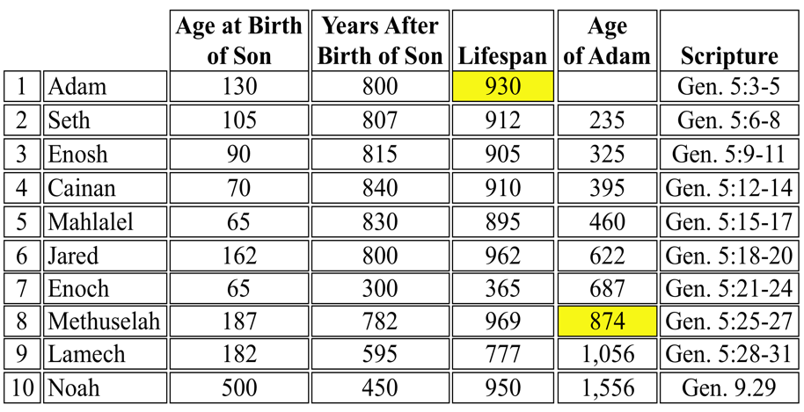

In looking at the above table, Adam – Noah spans 10 generations covering 1,056 years. Adam was alive and able to tell the story of creation to Noah’s grandfather – Methuselah. The average age was 858 years.

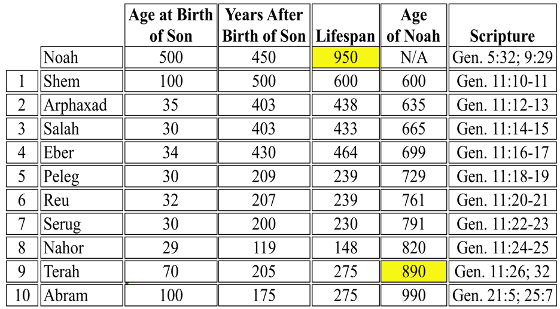

Regarding the above table, there are 10 generations from Shem to Abram covering approximately 1,090 years. Noah is alive at the time of Abram’s birth. The average lifespan during these 10 years is 334 years – likely due to the firmament being removed which many speculate was a key source of water for the flood. By the removal of the firmament, there was a loss of protection of ultraviolet rays.

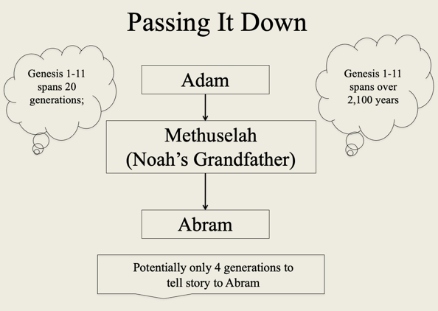

After reviewing the previous tables, the above diagram summarizes how few generations it took to communicate Chapters 1-11. This should bring us a sense of confidence in the accuracy of the story. The below diagram helps us understand Abram’s family tree. His father was Terah, and he had two brothers – Nahor and Haran. Haran died when he was young and was the father of Lot – making him Abram’s nephew.

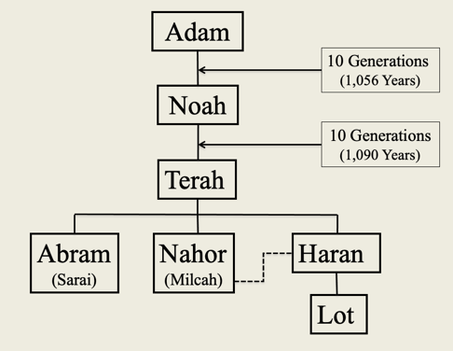

The New Testament provides some commentary on Abram. He is known as the father of all them that believe - from Romans 4:11. In James 2:23, he is labeled as the friend of God.
We aren’t given much information about Abram prior to the Lord speaking to Abram in Chapter 12. We’ve already gone through his genealogy. Scripture does tell us when and where he was living, and this is significant. His call occurred shortly after the destruction of Babel and dispersion of the nations – these were idolatrous times. This is confirmed in Joshua 24:2: “Joshua said to all the people, “This is what the LORD, the God of Israel, says: ‘Long ago your forefathers, including Terah the father of Abraham and Nahor, lived beyond the River and worshiped other gods.”
Hopefully, the below map will help us with the “where” Abram lived. The “River” referred to in Joshua is the Euphrates. Genesis 11:31 tells us they were living in Ur of the Chaldeans. This was a place of paganism including pantheism which identifies God with the universe, or regards the universe as a manifestation of God.

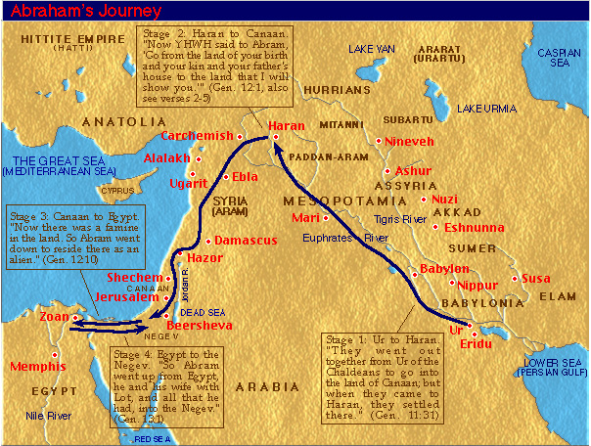

So, what we know of Abram is that despite the amazing accolades that Scripture gives to Abram, when and where he is at prior to his call is not good – right? We need to remember that for our lives. We may think we’re no good and why God would want anything to do us given our current state of existence, the Lord has a plan for you. Remember Jeremiah 29:11, “For I know the plans I have for you,” declares the LORD, “plans to prosper you and not to harm you, plans to give you hope and a future.” That was certainly the case for Abram, and it is also the case for you.
Now as we go forward, we need to equate what is going on with Abram and God is exactly what goes on with us as followers of Jesus. Genesis 12:1 tells us the first step, “The LORD had said to Abram, “Leave your country, your people and your father's household and go to the land I will show you.” From Acts 7:2-3 we read, “To this he replied: Brothers and fathers, listen to me! The God of glory appeared to our father Abraham while he was still in Mesopotamia, before he lived in Haran. ‘Leave your country and your people,’ God said, ‘and go to the land I will show you.’ Steven in his dispute with the Synagogue of the Freedmen in Acts 7:2-3 reveals that God appeared to Abram to begin his call. This is the first recorded “appearing” of God after the banishment of Adam and Eve from Eden
Again, referencing the below map, the call of Abram shows us the starting point of the life of faith – the first requirement is separation from the world and from our place in it by nature. He was called to leave his people and his country. This typifies our citizenship which is in heaven but we’re still in the world – therefore we’re called to walk upon the earth as a stranger and pilgrim. Abram’s call illustrates the heavenly calling of those of us who are members of the body of Christ. Abram’s father, Terah, was an idolator and Abram had become a believer in the living God, therefore it was expedient that Terah should be left behind.

The reason we’re doing this lesson on a line-by-line basis is because it reveals the fullness of Abram’s walk with God – both the good and the bad. Now he’s given the Three Commandments:

- He was to leave his own country
- He was to separate himself from his people and his father’s household
- He was to go to the land which God will show him

The Lord’s commands are rarely accompanied with reasons but they are always accompanied with promises, either expressed or understood. The promise to Abram is vague, probably intentional to test Abram’s faith. No mention of the land flowing of milk and honey. No mention that God was going to give it to him and his seed. Note the three-fold commandment and the corresponding three-fold promise found in Genesis 12:2-3, “(1) I will make you into a great nation and I will bless you; (2) I will make your name great, and you will be a blessing. (3) I will bless those who bless you, and whoever curses you I will curse; and all peoples on earth will be blessed through you.”
1) Making him a great nation was compensation for the loss of his country; 2) the blessing of Jehovah would more than make up for any loss of carnal joys he would lose by leaving his people; 3) He was to leave his father’s house, but God would make him the head of a new house – the house of Israel. Did he obey these commandments perfectly? Genesis 11:31 reveals that they are leaving Ur and heading to Haran. So, at this point, Abram is not being fully obedient – he’s taking his family and they are only going to Haran. Terah means delay, and by disobeying the second commandment, keeping his father’s household indeed caused a delay.
Once again, referencing the below map, notice that they’re traveling adjacent to the promised land – but not inside the promised land. Haran was the border town of the Babylonian region – located between Ur and Canaan; Haran was adjacent to – but not inside the promised land. This is how so many of us Christians live – on the edge of the fullness of the promise of God but residing on the border of God’s promises and the secular world. Like Abram, you don’t have to spend your whole life there – it takes faith to occupy the blessing. Abram moved on – so can we. Abram waited at least 15 years in Haran before moving on to the promised land

So, Abram’s response to God’s call was partial and slow, but now read Isaiah 51:2, “Look unto Abraham your father, and unto Sarah that bare you: for I called him alone, and blessed him, and increased him.” (KJV) We see the grace of God as He focuses on Abram’s ultimate obedience in this verse. This is even more the case in Hebrews 11:8, “By faith Abraham, when called to go to a place he would later receive as his inheritance, obeyed and went, even though he did not know where he was going.” Abram’s obedience in leaving Ur is singled out but no notice is taken by the Holy Spirit of his disobedience in taking his people and his father’s household – that sin had been blotted out. We need to remember God’s view is from beginning to end – He knows we’re going to stumble along the way, but His focus is where we end up – with Him. God doesn’t use perfect people because they don’t exist.
Let’s make an observation: God dealt with Babel in judgment. He deals with Abram in grace. Arthur Pink said, “According to His infinite wisdom, judgment only serves to prepare the way for greater manifestations of His redeeming love.” An example of Pink’s statement would be God’s judgment upon Israel resulted in the enriching of the Gentiles. His outpouring of Divine wrath in the Tribulation period will be but the precursor of Millennial blessedness. Judgment of the great white throne will be followed by the new heaven and new earth.
A second observation: Why Abram? Nothing apparent about him that appears to give him favor to God. So why Abram? Grace. We need to remember that constantly – there’s nothing we do apart from God that warrants His favor. He simply loves us. He prevents things that deserve to happen to us – that is mercy. He provides things to us we don’t deserve – that is grace.
It wasn’t until Terah, a symbol of the flesh, died, that separated Abram from the flesh and allowed him to move forward to an abundant life of faith. So, he journeys from Haran, through Shechem and arrives in Canaan.
In chapter 12, verse 7, we see God appearing to Abram. There is no record of Abram receiving any further revelation from God until his call had been fully obeyed. So, God rewards Abram’s faith and obedience by promising this land to his seed. At the second appearance, He reveals Himself to Abram for communion, and the result is that Abram erects an altar. It is not until there is real separation from the world that fellowship with God is possible. First the obedience of faith and then the communion and worship. Abram took communion in anticipation of Jesus; we take it in remembrance of Him.
Note that this promise in verse 7 includes the Jews and the Arabs (Palestinians through Ishmael) – it is not until God speaks to Jacob that the promise is limited to the Jews. So, Abram’s complete obedience took approximately 25 years – was God mad at Abram for taking so long? There’s no record of this. Moreover, Isaiah tells us in 30:18a, “Therefore the LORD will wait, that He may be gracious to you.” (NKJV) God wasn’t mad at Abram for his delayed obedience, and He is not mad at you. Taking steps of faith can be like a toddler taking his first steps. When he falls down, do we yell at him? No, we help him back up and encourage him to try again. Then we celebrate when he finally takes his first few steps. So, it goes with God and our walks of faith.
Genesis 12:8 reads, “From there he went on toward the hills east of Bethel and pitched his tent, with Bethel on the west and Ai on the east. There he built an altar to the LORD and called on the name of the LORD.” Bethel means “the house of God” and Ai signifies “a heap of ruin”, and it was between them that Abram pitched his tent – typical of our path today: the world on one side and God on the other. We see here the transformation of Abram going from having a home and property in Ur to now living in a tent – a sign of his transformation to a faithful follower of God – a pilgrim. His building of the altar signifies his dependency on and worship of God.
In verse 10 of chapter 12, we see Abram’s second failure. This is the first mention of Egypt in Scripture. Egypt is a symbol of an alliance with the world and reliance upon the flesh. Isaiah reminds us of the perils of the temptation of leaning towards the “Egypts” in our life, “Woe to those who go down to Egypt for help, who rely on horses, who trust in the multitude of their chariots and in the great strength of their horsemen, but do not look to the Holy One of Israel, or seek help from the LORD.” (Isaiah 31:1)
The famine was probably sent as a trial for Abram, and he did what most of us do – he sought relief from his difficulties rather than profit from the trial and seek the LORD. One sin typically leads to another. Failure in our love to God always results in failure to love to our neighbor. Abram assumes the title of the world’s worse husband. Right ladies? Genesis 12:11-13, “As he was about to enter Egypt, he said to his wife Sarai, “I know what a beautiful woman you are. When the Egyptians see you, they will say, ‘This is his wife.’ Then they will kill me but will let you live. Say you are my sister, so that I will be treated well for your sake and my life will be spared because of you.” She ends up in his Pharaoh’s harem and he ends up with a bunch of cattle, servants, and camels. What a deal! The story continues in Genesis 12:17, “But the LORD inflicted serious diseases on Pharaoh and his household because of Abram's wife Sarai. In verse 17, we see the LORD stepping in to make sure His will is going to be accomplished.
Moving into chapter 13, we see Abram getting the message, and he ends up back in between Bethel and Ai where he built the altar. This is repentance – turning around from your “trip to Egypt” and heading back towards a Godly path and place. We are then introduced to Abram’s nephew, Lot. Although he described as a righteous man in Scripture, Lot is really a symbol of a walk in the flesh. Throughout Scripture, the Holy Spirit provides us contrasting characters to demonstrate a life of walking with God to a life of walking in the ways of the world. The below offers a contrast of Abram and Lot.

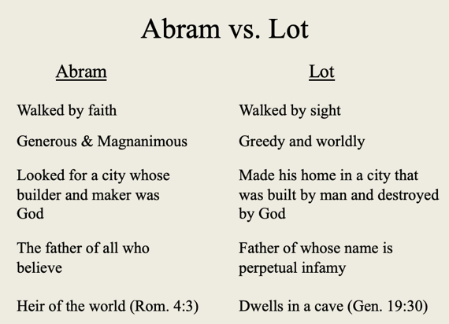

Abram is used as a symbol of faith, so in Chapter 13 we see Lot’s departure from Abram was really a symbol of the departure from faith. In verses 13:10-11, we see the steps that Lot took in his departure from Abram, “Lot looked up and saw that the whole plain of the Jordan was well watered, like the garden of the LORD, like the land of Egypt, toward Zoar. (This was before the LORD destroyed Sodom and Gomorrah.) So Lot chose for himself the whole plain of the Jordan and set out toward the east. The two men parted company: Note the pattern – it’s outlined in Joshua 7:21, “When I saw in the plunder a beautiful robe from Babylonia, two hundred shekels of silver and a wedge of gold weighing fifty shekels, I coveted them and took them.” The pattern – seeing, coveting, and taking - was set early in Genesis 3:6, “When the woman saw that the fruit of the tree was good for food and pleasing to the eye, and also desirable for gaining wisdom, she took some and ate it.”
We also see Lot’s progressive downfall from a life walking in faith as we read about his sojourn in Sodom:

- Lifted up his head and beheld
- Chose him all the plain of Jordan
- He separated himself from Abram
- He lived among the cities of the plain
- Pitched his tents near Sodom
- Dwelt in Sodom (Gen. 14:12)
- Sitting in the gateway of the city (Gen. 19:1)

What did Lot benefit by separating himself from Abram? Nothing.

The third lesson we learn from Lot is about his deliverance from Sodom. God warns Lot of his poor choices by allowing him to lose his possessions and be captured by the four kings. Despite the clear warning sign from God in losing his possessions and being taken into captivity, he doesn’t learn the lesson and ultimately will end up badly. He is delivered from his death by the sword of Abram. (Ephesians 6:17: Take the helmet of salvation and the sword of the Spirit, which is the word of God.) Again – Abram is a symbol of our faith, so Lot’s deliverance by Abram is a symbol of our deliverance from our sinful ways via our faith in Jesus. We come to this faith by believing the sword of the Spirit which is the Word of God. Abram acts as Lot’s advocate (1 John 2:1: My little children, these things I write to you, so that you may not sin. And if anyone sins, we have an Advocate with the Father, Jesus Christ the righteous. NKJV) As Lot had an advocate in his uncle, Abram, so we do also have an advocate with the father – Jesus Christ the righteous One.
In Chapter 14 we see the first war in the Bible, and we see the fruit of the character of a faithful and Godly man. Abram was not indifferent to his nephew’s well-being; there was no root of bitterness in him. In Abram, we see his righteous indignation that a brother has been taken captive by the enemy. Look at Galatians 6:1, “Brothers, if someone is caught in a sin, you who are spiritual should restore him gently. But watch yourself, or you also may be tempted.” Do you see the parallel in terms of spiritual captivity? May we all be sensitized to the Lord’s parable in Matthew 18:12-13, “What do you think? If a man owns a hundred sheep, and one of them wanders away, will he not leave the ninety-nine on the hills and go to look for the one that wandered off? And if he finds it, I tell you the truth, he is happier about that one sheep than about the ninety-nine that did not wander off.”
We find another symbol of the Lord’s patience and love - after witnessing an albeit slow obedience to the instructions of God and displaying Godly character in his dealings with Lot, that Abram is rewarded with a visit from a mysterious character, Melchizedek. Not much is offered about Melchizedek in Chapter 14 other than he is the king of Salem. We have to go to the 7th chapter of Hebrews to learn more about Melchizedek, “This Melchizedek was king of Salem and priest of God Most High. He met Abraham returning from the defeat of the kings and blessed him, and Abraham gave him a tenth of everything. First, his name means “king of righteousness”; then also, “king of Salem” means “king of peace.” Without father or mother, without genealogy, without beginning of days or end of life, like the Son of God he remains a priest forever.” (Hebrews 7:1-3)
There is much debate over whether or not Melchizedek is a Christophany or Theophany – a scene where Jesus arrives in the Old Testament. Those who say it is, point to the name King of Peace and related Isaiah 9:6 calling him the Prince of Peace. They also point to the 8th chapter of John’s gospel where Jesus claims he met Abraham. The naysayers point to the lack of genealogical record as well as the line verse 3 that he was “like the Son of God.” What really matters was the interaction between Melchizedek of Abram’s respect for Melchizedek – what did he do.

Melchizedek brought out the symbols of communion – bread and wine Genesis 14:18: “Then Melchizedek king of Salem brought out bread and wine.” He blesses Abram – the greater always blesses the lesser. Genesis 14:19-20, “he blessed Abram, saying, “Blessed be Abram by God Most High, Creator of heaven and earth. And blessed be God Most High, who delivered your enemies into your hand.” Abram gives him a tithe in Genesis 14:19, “Then Abram gave him a tenth of everything.”

Key Points in Chapter 12

- The call that came to Abram comes to each one of his believing children – the call for absolute confidence in God; the call to take Him at His word and step out in simple and unquestioning faith; the call to separate ourselves from the world to a life of pilgrimage in dependency upon God.
- The trial of Abram’s faith is also the lot of all his children. The failure of Abram is a solemn warning against being occupied with circumstances instead of with God. Look not at the famine but to God’s faithfulness
- Beware of going down to Egypt. The friendship of the world is enmity with God. Time spent in Egypt is wasted.
- As we see the in the failures of Abram maybe our own history, we need to remember and marvel at the longsuffering of God which deals in such infinite patience and grace with us.

Key Points in Chapter 13

- The certain accomplishment of God’s purpose

God’s purpose was to separate Abram (righteousness) from the land of his birth and from his own kinsmen (Lot - sin) in order to educate him and his in the knowledge and obedience of Jehovah. Isaiah 51:2 tells us Abram was called alone, yet he took at least two of his relatives (Terah and Lot) when he left Ur of the Chaldees – yet his purpose was ultimately realized here. The point here is that God’s will will be accomplished – regardless of our disobedience – Proverbs 19:21 tells us, “There are many plans in a man’s heart, nevertheless the LORD’s counsel—that will stand.”

- The Magnanimity of Abram

Magnanimous means generous in forgiving insult or injury – free from petty resentfulness. In Genesis 13:9, we see Abram foregoing his rights to eliminate the strife between his people and Lot’s – this is what Jesus did – He gave up His rights for the purpose of reconciling us sinners to the father.

- The Warnings Pointed Out by Lot’s Failures

His choice of residence - where we choose to reside or dwell has a profound impact on our choices. His yielding to the spirit of worldliness - we saw the pattern of his downfall – seeing, coveting, and taking. His miserable end – the loss of his wife to becoming a salt lick and his daughters getting him drunk to get impregnated by him.

Let’s summarize the interaction between steps of faith and God’s responses to them. Genesis 12:1, “The LORD had said to Abram, “Leave your country, your people and your father's household and go to the land I will show you.” God first promises to show him the land if he leaves his home and his people – Abram does leave but he takes Terah and Lot. Upon his arrival into the land, God appears to Abram and says He’s going to give this land to his offspring as noted in Genesis 12:7, “The LORD appeared to Abram and said, “To your offspring I will give this land.” Finally, we see the fullness of the promise of God in Genesis 13:14-17, “The LORD said to Abram after Lot had parted from him, “Lift up your eyes from where you are and look north and south, east and west. All the land that you see I will give to you and your offspring forever. I will make your offspring like the dust of the earth, so that if anyone could count the dust, then your offspring could be counted. Go, walk through the length and breadth of the land, for I am giving it to you.”
I don’t know about all of you, but this lesson was very convicting. We have the full promises of God from the Bible, but it is our unbelief that hinders us from enjoying to the fullest what is already ours in the purpose of God. I am so thankful for His longsuffering patience with me as I stumble along in regular defiance and unbelief. I cling to Philippians 1:6: being confident of this, that he who began a good work in you will carry it on to completion until the day of Christ Jesus.

