Lesson 8 Lecture
Genesis 27:1-30:43

Welcome! Today we get some insight into the family relationships surrounding Jacob. For me, one of the more reassuring aspects of the Bible is the fact that even the most blessed figures are presented as real people with both good and bad traits. In our lesson we get to see some pretty serious dysfunction in this family. If we’re honest, there’s some dysfunction in every family – I know there is in mine. But just in case you’re not sure if you have dysfunction in your family, I thought I could help you identify some examples by giving you the Top 10 Reasons You Know Your Family Is Dysfunctional.

10. More than half the addresses on your Christmas card list include the words, “State Penitentiary”
9.The FBI’s 10 Most Wanted list bears a striking resemblance to a picture in your family photo album
8. Your family vacations typically coincide with raises in the Nation’s Terror Alert status
7. Stephen King requests to attend your family reunion, so he can get some fresh material
6. There are airport screening devices outside each of your kid’s bedrooms
5. The family 4th of July celebration is monitored by the Nuclear Regulatory Commission
4. A “Kodak Moment” from the family Thanksgiving looks like an episode from the Jerry Springer show.
3. When you get a birthday present from a member of your family you have to ask, “Is it ticking?”
2. Your kids are the first to ever get detention in Sunday School
1. After hearing your family’s confessions and requests for forgiveness, Jesus, visibly shaken, says, “I’ll get back to you.”

The below chart should be helpful in keeping track of the key players in our reading and how they’re connected:

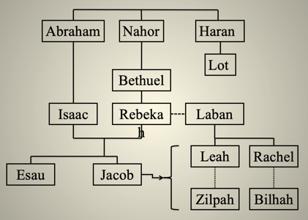
We’re going to get started with some character studies of some of the key players in today’s lesson. So, let’s start the character studies with Esau.
Esau typifies the non-believer. Genesis 25:27(a) telss us, “The boys grew up, and Esau became a skillful hunter, a man of the open country.” The Hebrew word for “hunter” is found in an evil connection:
- David calling out Saul for Saul’s unjustified pursuit of him (1 Samuel 24:11)
- Job speaking of God pursuing him in anger (Job 10:16)
- David asking that disaster hunt down men of violence in Psalm 140:11:
- Solomon warning of wicked women in Proverbs 6:26
- And in Micah 7:2: “All men lie in wait to shed blood; each hunts his brother with a net.”

“Man of the open country” – from Matthew 13:38 – the field is the world – the spiritual truth of Esau is revealed in this description. He lives for the flesh – he’s not interested in spiritual things. Esau is out in the field and comes home “famished”. That is living in the world – it does not satisfy – it leaves you wanting more of something that will never satisfy you. John 4:13 confirms this, “Everyone who drinks this water will be thirsty again.” Being the firstborn is a gift from God; Esau sold it for stew.

Per Jon Courson, in Esau, we have an interesting prophetic implication.

- Genesis 36:9: Esau is the father of the Edomites.
- Book of Obadiah is devoted to an indictment against the Edomites.
- God wages war on the Edomites because, Haman - an Edomite, planned to annihilate the Jews.
- The Edomites ultimately settle around Hebron – part of the west bank today – and became known as Idumeans.
- Around 47 B.C., Julius Caesar appointed Antipater – an Idumean as governor of the region. Antipater was the father of Herod – the infamous line of Herods.

In 70 A.D. when Titus led the army to destroy Jerusalem, he employed the Idumeans to act as friends of the Jews but they slaughtered them. This is the link between Edomites-Herod-Romans. Potential link to the antichrist. Ezekiel 25:14 tells us, “I will take vengeance on Edom by the hand of my people Israel, and they will deal with Edom in accordance with my anger and my wrath; they will know my vengeance, declares the Sovereign LORD.” From Romans 9:13, we learn, “Just as it is written: “Jacob I loved, but Esau I hated.” So, we see in Esau a stark picture of the enemy of those who are God’s chosen – the Jews and the church. Moreover, we see God’s attitude against those who are against His people. Isn’t that good news?
I have to admit that in my early years as a new believer, I had a problem with Jacob. I thought he was kind of complainer and conniver. However, through my “growing up”, God revealed to me that He didn’t have a problem with Jacob – so why should I? Preparing this lesson also helped. So, we learn that Jacob typifies the man of faith. Genesis 25:27(b) says this about Esau and Jacob, “The boys grew up - Jacob was a quiet man, staying among the tents.” The Hebrew word for “quiet” or “plain” is “tam” which is translated in other passages “perfect”, “upright”, or “undefiled”. “Staying among the tents” denotes that he was a stranger and a pilgrim in this scene – having no abiding city but seeking one to come. Jacob pursued the things of the spirit – the firstborn birthright and the blessing. Now we’ll get into the fact that his methods are clearly subject to questioning, but he is the counter to Esau – he is a man seeking the things of God.
Our next character review is Rebekah. She believed the promise God made to her in Genesis 25:23 that the older will serve the younger. Ideally, a parent shouldn’t have favorites among his/her children, but Rebekah favored Jacob. She also “forced” the timing of God’s plan via her schemes. Romans 2:1 provides the warning of messing with God’s plan, “You, therefore, have no excuse, you who pass judgment on someone else, for at whatever point you judge the other, you are condemning yourself, because you who pass judgment do the same things.” She ultimately would pay a price for her schemes – she would never see Jacob again.
Next, we get to Isaac. His partiality towards Esau was a plain disregard of God’s word to Rebekah that Esau should serve Jacob. Isaac trusted in his flesh (smell and feel) believing it was Jacob instead of trusting in the word (his voice). That’s how we become deceived.

The four elements that comprise Isaac’s blessing of Jacob:
- Genesis 27:25b-26 – involves a tender meaningful touch
- Genesis 27:27 – a spoken message of a valued, valuable evaluation – an affirmation of perception by the parent
- Genesis 27:28-29 – a word of destination
- Genesis 27:34b – 37 – a promise of continued commitment – he’ll stand with him

Maybe your earthly father has not blessed you, but your heavenly Father seeks to bless you. Do you believe that? I grew up in a home where blessings were non-existent and encouragement was few and far between. It continues to be a process for me in trusting the blessings God has for me. It’s not God’s fault – I’m just leaning on my own understanding of human nature – not God’s. If any of you share that challenge in your walk with God, memorizing Proverbs 3:5 will help. It says, “Trust in the Lord with all your heart and lean not on your own understanding.” This especially applies to the idea of believing in the fact that God seeks to bless you.
We then move on to Rebekah’s brother, Laban. He was one greedy hombre – Genesis 24:30-31: As soon as he had seen the nose ring, and the bracelets on his sister's arms, and had heard Rebekah tell what the man [Abraham’s servant] said to her, he went out to the man and found him standing by the camels near the spring. “Come, you who are blessed by the LORD,” he said. “Why are you standing out here? I have prepared the house and a place for the camels.” He was also deceitful – switching out Rachel for Leah at Jacob’s wedding; moving the cattle Jacob picked out.
Laban was used by the LORD to be an instrument of judgment upon and instruction for Jacob regarding:
1. Humble submission to Laban to get Rachel
2. Reminded the importance of the rights of the firstborn in Leah
3. Teaching him patience in working for many years to get Rachel

There are some key points in our lesson today that demonstrate examples of God’s wisdom and sovereignty.

- Marriage with one spouse. We see this in the battle between Leah and Rachel the wisdom of God’s concept of marriage; multiple spouses brings multiple headaches. Purity brings peace. Matthew 6:24 reminds us, “No one can serve two masters. Either he will hate the one and love the other, or he will be devoted to the one and despise the other.”
- God’s Sovereignty tells us that the order of nature is not necessarily the order of grace. Abraham was probably not the first son of Terah; Isaac was the younger son of Abraham; Joseph was not the oldest son of Jacob.
- The principle of Divine retribution – Job 4:8: “As I have observed, those who plow evil and those who sow trouble reap it.” Galatians 6:7: “Do not be deceived: God cannot be mocked. A man reaps what he sows.”

Examples of sewing what you reap:
- Pharaoh, King of Egypt, gave orders that every son of the Hebrews should be drowned – and so in the end he was drowned
- Korah caused a cleft in the Congregation of Israel (Numbers 16:2-3), and so God made a cleft in the earth to swallow him (16:30)
- Saul of Tarsus stood by and consented to the stoning of Stephen, and he would be stoned by the Jews in Lystra

The best example of sewing what you reap? Jacob
- Deceived his father but was deceived by his father-in-law – Jacob made himself out to be the younger for the elder to deceive Isaac; the elder daughter (Leah) is given instead of the younger (Rachel)
- In deceiving Jacob in the matter of Leah, Laban tricked Rachel; later Rachel tricks Laban (Genesis 31:35)
- Jacob deceived Isaac by covering his hands and neck with the skins of the kids of the goats; Jacob would be deceived by his sons when they dipped Joseph’s coat in the blood of a kid of the goats (Genesis 37:31)
- Jacob deceived Isaac regarding his favorite son; Jacob was deceived regarding his favorite son, Joseph.

Main point behind sewing what you reap? God is just, and He is not mocked (Hebrews 2:2). This is not done in anger but in love; not in judgment but for the conscience and heart so as to bring them to judge themselves for their evil doing.
Our lesson also offers symbolism of Divine foreshadowing. There’s the symbolism of the gospel:
- Jacob found acceptance with his father and received his blessing because he sheltered behind the name of the firstborn, the beloved son, and was clothed with his garments which diffused to Isaac an excellent odor.
- We as sinners, find acceptance before God and receive His blessing as we shelter behind the name of His beloved Firstborn, and as we are clothed with the robe of righteousness by the merits of Jesus who loved us and gave himself up for us as a fragrant offering and sacrifice to God (Ephesians 5:2).

From Genesis 29:27 – fulfill her bridal week – demonstrating that the Biblical week is equivalent to 7 years which is significant in regards to the prophecy of 70 weeks as outlined in Daniel 9.

Jon Courson points out in each of the patriarchs, there is a foreshadowing of truth in the believer:
- Abraham – the truth of God’s sovereignty and the life of faith; election; Abraham is the “first”
- Isaac – Divine sonship and the life of submission; new birth; the “supernatural birth” and the heir of the father’s house
- Jacob – God’s grace and a life of conflict; manifestation of the two natures; the servant

One of the more interesting prophetic components in our reading is the relationship of the names and order of Jacob’s sons and the future of the Nation of Israel – at least through part of the Old Testament. The below provides some analysis on these 12 sons of Jacob’s names.

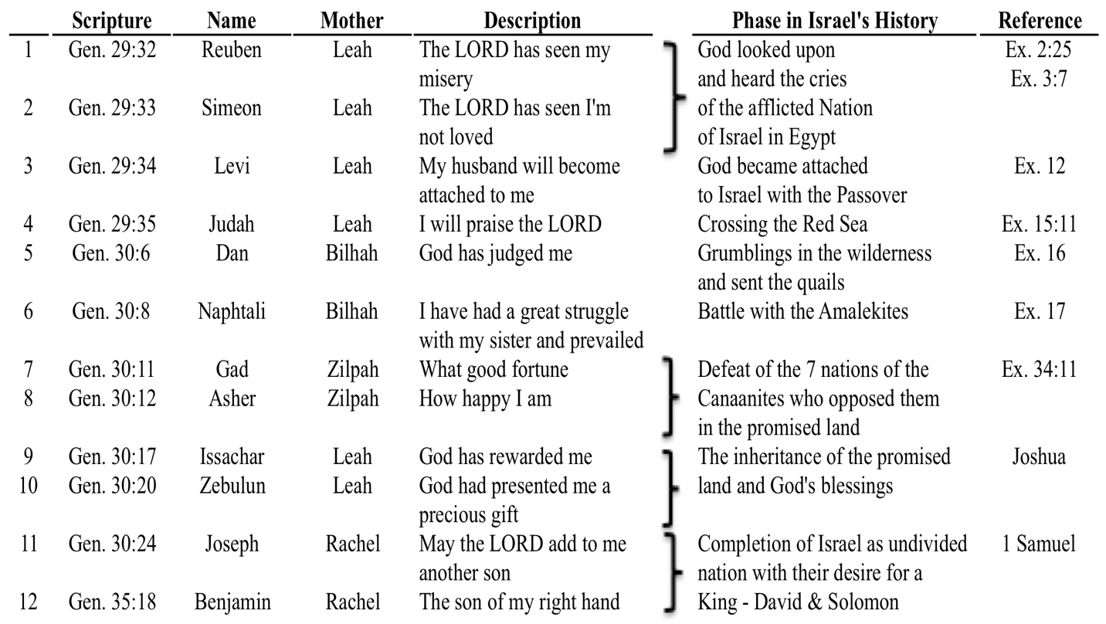

What lessons do we learn in today’s reading?
- We can’t barter, or trade/sell, God’s privileges for carnal satisfaction (Esau)
- Beware of doing evil that good may come (Rebekah/Jacob)
- We need to submit to God’s grace to prevent natural affections overriding love for God and His revealed will. (Rebekah)
- Remember the unchanging law of sowing and reaping
- Learn the utter futility of seeking to foil God
Romans 9:16: It does not, therefore, depend on man's desire or effort, but on God's mercy.
Proverbs 19:21: Many are the plans in a man's heart, but it is the LORD's purpose that prevails.

In our reading we find the fulfillment of the promises of God. Let’s take a look at the promises God makes to Jacob:
- Genesis 28:13b-15a: first thing God promises Jacob is His presence;
- Genesis 28:15b: next His protection
- Genesis 28:15c: then – preservation
- Genesis 28:15d: finally, He would complete the work which He had begun

Jacob believes, and he becomes a new man. The evidence of Jacob’s conversion is:

- Genesis 28:17-18 – true conversion is seen in his worship
- Genesis 28:22 – true conversion is seen in one’s work (James 2:20)
- Genesis 29:1 – true conversion is seen in one’s walk

For those of you who might be feeling distant from God, or maybe you’re not walking in a manner that would make you think God would want anything to do with you – or maybe your family is in a mess, please remember what God says:
- Romans 8:38-39: For I am convinced that neither death nor life, neither angels nor demons, neither the present nor the future, nor any powers, neither height nor depth, nor anything else in all creation, will be able to separate us from the love of God that is in Christ Jesus our Lord.
- Romans 8:1: Therefore, there is now no condemnation for those who are in Christ Jesus

- In Jesus, nothing can separate you from God
- In Jesus, you are not condemned
- In Jesus, His presence with you is promised
- In Jesus, He promises His protection
- In Jesus, You are preserved by Him

And Philippians 1:6 reminds us that if we’re confident of all of this, that He who began a good work in you will carry it on to completion until the day of Christ Jesus. Praise the Lord – let’s pray.

