Lesson 13 Lecture
Genesis 45:16-48:22

Greetings! In today’s reading about Joseph, we’re going to find that Joseph is a type of Jesus. He is a symbolic presentation of the progression in our relationship with a God who saves His people. Before Joseph’s brothers know that he is alive, they are living in a famine existence. They’re burdened by their guilt of their sin for what they did to their brother and the impact it had on their father. So, it is in our lives before we come to know the Lord – we are starving for the real bread of life. We are going through our lives with the guilt and shame and the burden of our state of unforgiveness.
What does Joseph say to reveal himself to his family members?
- “I am Joseph” – I Am
- “Does my father still live?” – his first concern shows the love he has for his father
- “Please come near to me” – he shows his desire for his loved ones to come to him (Matthew 11:28 - “Come to me, all you who are weary and burdened, and I will give you rest.)
- “I am Joseph your brother whom you sold into Egypt” – confirms again who he is and the truth so that they will believe
- “And now, do not be distressed and do not be angry with yourselves for selling me here” – an extension of forgiveness
- “Because it was to save lives that God sent me ahead of you. But God sent me ahead of you to preserve for you a remnant on earth and to save your lives by a great deliverance. So then, it was not you who sent me here, but God.” – reveals that God had a purpose in his life that involved suffering from the effects of their sin – the purpose was to save a remnant

Regarding and Pharaoh and Joseph, the Pharaoh could be a type of “Father” – note his responses to the news of the revelation of Joseph to his family:
- Pharaoh is pleased to learn of the reconciliation of Joseph and his family
Colossians 1:19-20: For God was pleased to have all his fullness dwell in him, and through him to reconcile to himself all things, whether things on earth or things in heaven, by making peace through his blood, shed on the cross.
- “Bring your father and your households and come to me; I will give you the best of the land of Egypt, and you will eat the fat of the land.”
John 14:2: My Father’s house has many rooms; if that were not so, would I have told you that I am going there to prepare a place for you?

Joseph sends his brothers out to tell the truth – that he is alive; he gives them gifts. Imagine what they were thinking on the way to tell Jacob Joseph was alive? Dad – “we’ve got some good news and some bad news”. How about, “Have you ever heard of Candid Camera?” Or maybe, “That blood on the Joseph’s coat – well couldn’t tell between him and a kid goat – he was having a bad hair day.” Any of that sound familiar to us? Do we have a problem sharing Jesus because we are afraid, we’re going to be exposed for who we are? We shouldn’t – the news is that good, and one of the core messages of the Gospel is that there is no condemnation in Christ – we are totally forgiven! Jacob believed that Joseph was dead, but it took him awhile to believe he was alive. Why? Who was bringing them the message? Proven liars; sinners. He believed the lie because it was bad, but he wouldn’t believe the truth because it was too good. It was only until he heard the words of Joseph and saw the evidence of Pharaoh’s goodness to them, Jacob’s spirit was revived. This is so for us as it is when we receive the Word of God and accept the goodness of God’s gift manifested through Christ’s atoning sacrifice, we are born again of the Spirit. John 3:3 confirms this, “Jesus (the Word) replied, “Very truly I tell you, no one can see the kingdom of God unless they are born again.”
God Honors Obedience and Those Who Seek Him. Jacob modeled wisdom and obedience – Genesis 46:1: “So Israel set out with all that was his, and when he reached Beersheba, he offered sacrifices to the God of his father Isaac.” Beersheba was the same place his grandfather, Abraham, called on the name of the LORD (Genesis 21:33) and his father, Isaac, called on the name of the LORD (Genesis 26:25). He wanted to make sure that what he was doing was acceptable in the Lord’s sight.
Genesis 46:2-3: “And God spoke to Israel in a vision at night and said, “Jacob! Jacob!” “Here I am,” he replied. “I am God, the God of your father,” he said. “Do not be afraid to go down to Egypt, for I will make you into a great nation there. I will go down to Egypt with you, and I will surely bring you back again. And Joseph’s own hand will close your eyes.” God did not withhold Jacob from seeing his beloved son – what was really good for him. God does not withhold from us what is really good for us. And God is good!

- Psalm 13:6: I will sing the LORD’s praise, for he has been good to me.
- Psalm 34:8: Taste and see that the LORD is good; blessed is the one who takes refuge in him.

Upon learning of the good news Jacob goes to Beersheba. Beersheba – one of the uttermost cities of the tribe of the children of Judah (Joshua 15:21, 28)

Abraham planted a special tree – commemorating:

A place where God spoke
Genesis 21:17 – Hagar
Genesis 26:24 – Isaac
Genesis 46:2 – Jacob
1 Kings 19:5 - Elijah

A place of Oaths
Genesis 21:31 – Abraham and Abimilech – “Well of the Seven”
Genesis 26:33 – Isaac and Abimilech – Peace Agreement

So, this place is linked to the tribe of Judah;
- It is a place where a special tree exists
- It commemorates God speaking to His loved ones
- It was a place that signified an oath of perfection (#7 is a symbol of perfection) and peace
- What other place offered all of this? The Cross.

The lion of the tribe of Judah would go to the tree at Calvary. On the cross, God spoke to the world, “I forgive you” – if you will believe in Me. For those who do believe, He made an oath in John 3:16, “For God so loved the world that he gave his one and only Son, that whoever believes in him shall not perish but have eternal life.” And the fruit of that oath is described in Isaiah 26:3, “You will keep in perfect peace those whose minds are steadfast, because they trust in you.”

There are some great nuggets in Chapter 46.

- Regarding Genesis 46:13 - some scholars think Job is the oldest book of the Bible written by an unknown author; however, others contend that Issachar has a son named Job, and he may be the Job of the Book of Job. If you chart the chronology, you find Moses – who could have authored the Book of Job – would have been 55 years old at the time when this particular Job was on the scene, making him the right age to have penned the book that uniquely chronicles the patience and power of faith under fire.
- From Genesis 46:14, Joseph’s gentile wife speaks of us, the church, as the bride of Christ, while the nation Israel is the wife of Jehovah. (Hosea 12:12)
- Genesis 46:26: Sixty-six came out of Canaan – six is the number of man.
- Genesis 46:27: Jacob, Joseph, and Joseph’s two sons make it 70 – 7 is the number of perfection, so when you add Joseph – a type of Jesus – it is perfect.
- Genesis 46:28: “Goshen” means “To draw near”. “Judah” means “praise”. Therefore, it is not coincidental that Judah led the way to Goshen, for, as the psalmist declared, we enter the gates of our heavenly Father with thanksgiving, and into His courts with praise (Psalm 100:4). Praise is the soil that allows the fruit of joy to thrive. Praise draws us in and causes us to be cognizant of the Lord’s presence. Thus, it was additionally fitting for Judah to lead the way to Goshen, for from Judah would come Jesus, the praiseworthy One (Revelation 5:5).
- Genesis 46:29-30: The image of the reunion of Jacob and Joseph – the father so grateful to see his beloved son alive – should give us a hint at the reunion the Father and Jesus had after His ascension.
- Genesis 46:31-32: Following the reunion with his father, Joseph becomes a mediator for his family as he goes before Pharaoh on their behalf. Hebrews 7:25 reminds us: Therefore, he is able to save completely those who come to God through him, because he always lives to intercede for them.
- Genesis 46:33-34: Why would Joseph instruct his brothers to tell Pharaoh they are shepherds when shepherds are at the bottom rung on the social ladder – they were untouchable – they weren’t allowed to enter the temples of Egyptian deities?
- Joseph, a type of Jesus, wanted his family to be marked people – separate from the Egyptian culture – a symbol of the world. Mark 10:9: Therefore what God has joined together, let no one separate.” 2 Corinthians 6:17: Therefore, “Come out from them and be separate, says the Lord. Touch no unclean thing, and I will receive you.”

In order to fulfill the great commission, we need to go into the world and minister to sinners. However, we are to separate ourselves from them in how we live. There’s an old saying that says, “For every 100 people, 1 will read the Bible and 99 will read the Christian.” If we’re not living lives separate from the world, what attraction is there for the members of the fallen world when they’re looking for something better? We need to be careful, though, that we’re not so heavenly minded, that we’re no earthly good.

We also see many examples of God’s amazing grace and blessings in today’s reading:

- Genesis 47:1-2: Joseph presents his brothers, who had treated him horribly, to Pharaoh absent of accusation showing amazing grace.
- Deuteronomy 4:31: For the LORD your God is a merciful God; he will not abandon or destroy you or forget the covenant with your ancestors, which he confirmed to them by oath.
- Jude 24: To him who is able to keep you from stumbling and to present you before his glorious presence without fault and with great joy

Jacob blesses Pharaoh. Jacob, being a symbol of faith in God, and Pharaoh – a symbol of the world. Hebrews 7:7: And without doubt the lesser is blessed by the greater.

Genesis 47:11-26: pictures the Millennium – when Jesus will rule and reign on earth:

- Verses 11-12: Joseph’s grace to Israel
- Verses 13-22: Joseph’s government over Egypt
- Verses 23-26: Joseph’s goodness for all

A. Joseph showing grace to Israel in their position (Verses 11-12)
- He places Israel in the best part of the land of Egypt. Israel will have the best of the land in the Millennium. “The LORD will make you the head, not the tail. If you pay attention to the commands of the LORD your God that I give you this day and carefully follow them, you will always be at the top, never at the bottom.” (Deuteronomy 28:13)
- According to Ezekiel 48, in the millennial kingdom, there will be portions of land given each of the 12 tribes.

B. Joseph’s Government over Egypt (verses 13-22)
- Verses 13-14: First step he takes to deal with the famine is to gather all the money to the throne. Those who have money are worried about it – those who don’t are concerned about getting it.
- Verses 15-17: Next step he takes is he makes everyone bring all their possessions – notice he keeps providing for them as they give him all they have. This is how it will be in the Millennium.
- Verses 18-20: He then takes all their property – he doesn’t want divided loyalties or human rivalries property so often brings.
- Verse 21: He scattered the people (Genesis 11:9; Acts 1:8)

This is also a symbol of our relationship with the LORD. The more we surrender our lives to Him, the more we find Him providing for us. Why do you think he did this? The “pack” mentality gets broken up.

C. Joseph’s Goodness for all (verses 23-27)
- He gives them seed to plant; all he asks is that 20% of the harvest goes to Pharaoh. Anyone here think giving 20% to the government is a bad deal?
- Another Jesus/Joseph moment – he provides for their needs by giving them seed. They proclaim they are saved and offer themselves as servants. By the Word of God (Luke 8:11), we are saved from our sins and gladly become servants.
- Verse 27: Jacob and his sons thrived in Goshen – so it will be for Israel in the Millennium

Genesis 48:3-5: Joseph and his sons bless Jacob by coming in to him, but they end up getting blessed. This is the “secret” perk of the ministry

Matthew 7:2: For in the same way you judge others, you will be judged, and with the measure you use, it will be measured to you.
It’s in giving that we get
It’s in praying for the sick we get healthier
It’s in cheering for the discouraged that our emotions are lifted
It’s in explaining the truth that our own understanding becomes more clear

Jacob’s blessing of Joseph’s sons, were counter to what Joseph expected, but it was right on in God’s eyes – Ephraim’s tribe was the predominant tribe of the 10 northern tribes in Israel
Challengers to the Bible’s perfection point at the variability in what constitutes the “12 tribes of Israel”. There are admittedly differences, but most of them are explainable. The below table offers 5 of the 24 presentations of the 12 tribes.

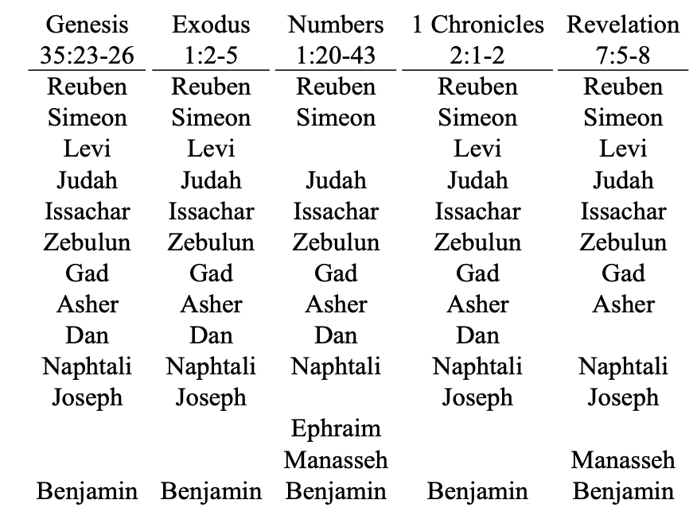

The Genesis list are the 12 sons born to Israel; the Numbers list are the tribes that got land inheritance after the Exodus; and the Revelation list are those tribes that will compose the 144,000 to witness during the Tribulation. In those cases where Levi is left off, it is likely due to the fact that the Levites were not allotted land – their inheritance was the care of the temple, and they received tithes and offerings from the other tribes. Because Jacob claimed Joseph’s sons, Ephraim and Manasseh, sometimes Joseph is included and the sons are left off and sometimes it’s visa versa. The curious one is why Dan is left off in Revelation 7 and Joseph and Manasseh are combined but Ephraim is left off. As far as Dan goes, it may be because of Genesis 49:17 where Jacob prophesizes: “Dan will be a serpent by the roadside, a viper along the path, that bites the horse's heels so that its rider tumbles backward.” Hosea wrote, “Ephraim will be laid waste on the day of reckoning. Among the tribes of Israel, I proclaim what is certain…Ephraim is oppressed, trampled in judgment, intent on pursuing idols” Hosea 5:9,11. Is there some inconsistency? Yes, but much of it is explainable, and any remaining component that isn’t explainable is not worthy of calling into question the infallibility of the Scriptures.

From 48:21, we get a sobering Realization – “Then Israel said to Joseph, “I am about to die.” This is not a popular topic – even for Christians – but it is a certainty for every one of us in this room. Israel/Jacob has chosen to deal with the inevitability of his demise. We see here him living out the truth of what Psalm 48:14 says, “For this is God, Our God forever and ever; He will be our guide even to death.” Jacob lived in Confident Expectation – 48:21b: “but God will be with you.” Jacob is a great example for us – clearly a flawed individual, but he personally experienced the faithfulness, blessings, and grace of God – despite his behavior. He didn’t need life insurance because he had life assurance. He passed that on to his son and grandsons.

A Glorious Continuation – 48:22: “And to you I give one more ridge of land than to your brothers, the ridge I took from the Amorites with my sword and my bow.” There’s no record of Jacob doing this – he’s speaking of it as if he’s certain it’s going to happen – his certainty is so much that he’s speaking as if it already has happened. Romans 8 tells us we are glorified. Have we physically been glorified? No, but it’s going to happen with certainty, so the Bible speaks about it as if it has already taken place.
All of the lecturers who have presented on the story of Joseph have noted that he is a type of Jesus. In our reading today, we reviewed the blessings of those who received the good news that Joseph was alive. The real point that we need to understand is, what blessings do we, as followers in Jesus Christ, receive upon our learning that Jesus is alive? There are too many to count, but I wanted to narrow it down to four:

- Total Forgiveness – Past, Present, and Future
Psalm 32:1: Blessed is the one whose transgressions are forgiven, whose sins are covered.
- Blessings of being reconciled to God and the family of God
Colossians 1:22: But now he has reconciled you by Christ’s physical body through death to present you holy in His sight, without blemish and free from accusation
- Realization of God’s provision when we surrender everything to Him
Philippians 4:16: And my God will meet all your needs according to the riches of his glory in Christ Jesus.
- There is a purpose to suffering, and it leads to things beyond our imagination
Romans 8:18: I consider the present sufferings are not worth comparing with the glory that will be revealed in us.

I cannot underscore the power of this blessing. Next to calling into question the existence of God, I can think of no other area Satan attacks more than in the area of us believing we are totally forgiven based on our faith in Christ’s work on the cross. If we all truly believed this core truth of the Scriptures, our lives would change instantaneously. An intimate relationship with God is the best thing any human can ever experience. The next best thing is sharing it with other fellow believers. I am totally blessed by being a part of this beautiful family of reconciled sinners.

When we choose to hold on tighter to God than we do things of this world, we’ll let go of them and grab hold of Him. He provided for his people in Egypt, and He’ll provide for His people today. God doesn’t change. For over 20 years, Joseph experienced great suffering for doing nothing but being a chosen one of God’s. Even though he had dreams of one day ruling over his family, I am certain he couldn’t imagine what would transpire.
For those of us who are experiencing suffering today, I simply extend a message of compassion. I know it hurts; I know it doesn’t seem fair; I know you want relief. I understand. Even though it may not seem like it at times, but God does, too. He does understand, and He does care. We need to remember that Jesus experienced great suffering as well, and in the end, there was no one to support Him. This lesson showed us the blessings of those who benefited from the realization that Joseph was alive. Forgiveness, reconcilement, provision, and purpose in suffering. The rest of the chapters of each of our lives extend into eternity because Jesus is alive. My encouragement for those of you who are not in a season of suffering is to come along side those who are suffering and simply listen and hold their hands. Quoting Bible verses is great, but there is nothing like the loving touch from a reconciled member of the family of God. It is by you that those who are suffering will begin to see the glory that will be revealed in us because Jesus is alive. Let’s pray.

