People of the Word
“Oracles” Isaiah 17:1 – 21:17
Chris Grattan

The title of this lecture “Oracles” is so appropriate, not only for this week’s study, but also for the book of Isaiah, and really the whole Bible!

The word “Oracle” is a Divine Utterance, a message or Word from God to humanity. It is a prophecy or pronouncement delivered by God through a prophet or intermediary. These prophecies are an authoritative message (by God) to provide guidance, promises, or judgment.

I have heard that there are over 1,800 prophecies in the Bible (some estimates have this number as high at 3,500). There are believed to be over 100 prophecies in the book of Isaiah, many designated as being Messianic prophecies, because they would be fulfilled by the coming Messiah!

In our study this week, from chapters 17 – chapter 21, there are distinct prophecies in each of these chapters. God makes it very clear, starting three of these chapters by saying, “A prophecy against.”

Think about the great importance of God telling His people (and really the whole world) things that would take place tens of years and many cases hundreds of years before they happen. That’s the power of trusting God’s Word, trusting His promises, because all have happened exactly as He said!

The Southern Kingdom of Judah was corrupt and following idols. God says to them (through Isaiah) in Isaiah 41:21-23 ²¹ “Present your case,” says the Lord. “Set forth your arguments,” says Jacob’s King. ²² “Tell us, you idols, what is going to happen. Tell us what the former things were, so that we may consider them and know their final outcome.
Or declare to us the things to come, ²³ tell us what the future holds, so we may know that you are gods. Do something, whether good or bad, so that we will be dismayed and filled with fear.

God is telling His people, “Who else can tell you of future events and make them happen exactly as I’ve said?”. As God speaks through Isaiah in chapter 46:9-10, ⁹ “Remember the former things, those of long ago; I am God, and there is no other; I am God, and there is none like me. ¹⁰ I make known the end from the beginning, from ancient times, what is still to come. I say, ‘My purpose will stand, and I will do all that I please.’”

God will do what He says! God says in Psalm 138:2b (from the New King James Version) “For You have magnified Your word above all Your name.”

I’m only 60 years old, but I remember at time when someone would look you in the eyes, shake your hand, and give you their word, and their word was their bond! This is what God is doing through His “oracles”, through His prophets!

Our study this week is a continuation of the oracles found in Isaiah chapters 13-23. God has already told what will happen to Babylon, Assyria, the Philistines and Moab. Today’s lesson begins with God telling His people exactly what will happen to Damascus: Isaiah 17:1 A prophecy against Damascus: “See, Damascus will no longer be a city but will become a heap of ruins.”

Some theologians believe that this prophecy of Damascus is yet to be fulfilled (as an end-times prophecy) because Damascus is still a city today and the reference to “become a heap of ruins”, makes it sound like utter destruction. However, the reference (or prophecy) is that Damascus will cease to be a city during this time.

Before I continue, I wanted to take a look at 2 different maps. The first is a map during the time of Isaiah:
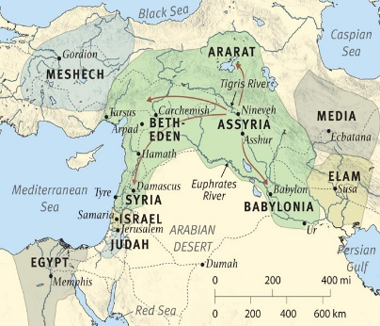

The next is a map of the same region, but this is how it looks today:

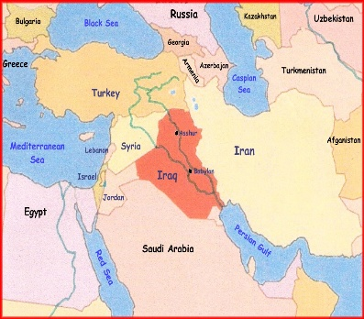

We see this reference to judgment coming upon Damascus and then in verse 4 we see Isaiah reference the judgment that will also come upon the Northern Kingdom of Israel: Isaiah 17:4 “In that day the glory of Jacob will fade; the fat of his body will waste away…
The name Jacob (like Ephraim) is used in reference to the Northern Kingdom of Israel. The glory of Jacob will fade, is speaking of Isreal’s might, population, prosperity, splendor, dignity, and honor. All this glory will fade, will be brought low, languish, and be in distress.

The prophecy in verse 4 goes on to say, “The fat of the body will waste away.” - This is truly a reference to how sin causes death, how it causes the body to waste away. We see a similar references in Ezekiel 4:17 (which is speaking of the siege of Jerusalem) “For food and water will be scarce. They will be appalled at the sight of each other and will waste away because of their sin.”

The King James Bible puts it this way: The fatness of his flesh shall wax lean: like a man in a consumption, that is become a mere skeleton, and reduced to skin and bones: the meaning is, that all their wealth and riches should be taken away.

Destruction will come upon Damascus and then upon Israel! We see in chapter 17 that a remanent of the faithful will remain in Israel; however, the leadership and a vast number of the people had turned from God and now received these powerful words of judgment: “You have forgotten God your Savior; you have not remembered the Rock, your fortress.” Isaiah 17:10a

You have forgotten is to willfully forget, to ignore, to cease to care about. Not remembering is similar; it’s a willful decision not to bring something back to your memory. What a scary place to be, that you willfully ignore the only One that can bring salvation!

Damascus was the first to fall in approximately 734-732 BC, Assyrian records show that Damascus withstood a 2-year siege but ultimately fell with King Rezin being slain and all the nobles impaled upon stakes and the city and all surrounding cities were burned to the ground! The Targum (ancient interpretation of the Hebrew Bible) states that Damascus’ walls were demolished, houses were pulled down, and its inhabitants were carried away as captives. We also see this referenced in 2 Kings 16:9 The king of Assyria complied by attacking Damascus and capturing it. He deported its inhabitants to Kir and put Rezin to death.

Damascus was utterly destroyed, exactly as the prophecy stated! And now, because of their depravity, God turned Assyria toward Israel for judgment. The destruction is referenced in 2 Kings 17:6 In the ninth year of Hoshea, the king of Assyria captured Samaria and deported the Israelites to Assyria. He settled them in Halah, in Gozan on the Habor River and in the towns of the Medes.

Well, with these oracles, we’re certainly in the midst of the “doom and gloom” portion of Scripture, aren’t we? There is a very little way to jazz up history except to learn from it. One thing we learn is that God always warns before judgment, not only what is to come, but why.

As we move on from the oracle against Damascus, God turns our attention to the region of Ethiopia and the rivers of Cush.

Chapter 18, Verse 1 & 2: ¹ Woe to the land of whirring wings along the rivers of Cush, ² which sends envoys by sea in papyrus boats over the water. Go, swift messengers,
to a people tall and smooth-skinned, to a people feared far and wide, an aggressive nation of strange speech, whose land is divided by rivers.

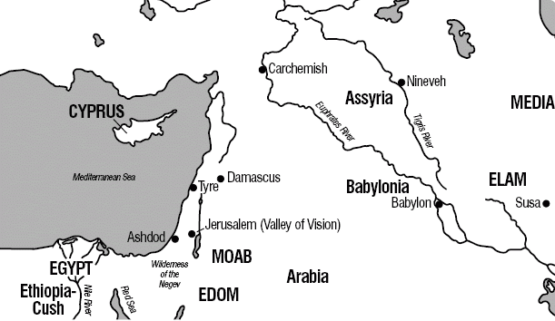

This is a prophecy in reference to Cush (Ethiopia) around 700 BC. Tirhakah was the crown prince of Cush during this time. Not only was Ethiopia near the Nile river and its tributaries, but it was also known for the swarms of buzzing flies.

What we are seeing in this chapter is the Ethiopians planning to come against the Assyrians. The Ethiopians are sending messengers to Hezekiah, the King of the Southern Kingdom of Judah, to seek an alliance. God, however, had a different plan for dealing with the Assyrians!

God was about to do something miraculous that the world would see! This is referenced in Isaiah 18:3 “All you people of the world, you who live on the earth, when a banner is raised on the mountains, you will see it, and when a trumpet sounds, you will hear it.” A banner raised and trumpet sounds isn’t to be taken literally, but is a reference to the event that is coming against the Assyrians, an event that will be so loud and clear that it would be heard by all.

In the year 701 BC, Hezekiah was king of Judah, one of the few “good” kings. The king of Assyria, Sennacherib and his army were on the hillside outside Jerusalem, ready to lay siege. King Hezekiah prayed to the Lord for deliverance, and what happens next is the banner and trumpet:

2 Kings 19:35-36 ³⁵ That night the angel of the Lord went out and put to death a hundred and eighty-five thousand in the Assyrian camp. When the people got up the next morning—there were all the dead bodies! ³⁶ So Sennacherib king of Assyria broke camp and withdrew. He returned to Nineveh and stayed there.

The Ethiopians and the whole world would have heard of this great event and we chapter 18 closes with gifts brought by them to the Lord Almighty!
Before we move on from chapter 18, let’s look again at verse 4:: Isaiah 18:4 This is what the Lord says to me: “I will remain quiet and will look on from my dwelling place, like shimmering heat in the sunshine, like a cloud of dew in the heat of harvest.”
What an amazing image we get here of the perfect calm of God. As the Ethiopian’s and the Assyrian’s are bustling and hurrying around, making schemes and plans, God remains calm and quiet. Not only is this a reference to the time of Isaiah, but also a message to us. We need to remember that God is in full control. In the midst of our storms and struggles to find solutions, God has a plan; He is in control!

I’m reminded of the scene when Israel came the banks of the Red Sea, the Egyptian army coming to kill them. The Lord spoke through Moses: Exodus 14:13 Moses answered the people, “Do not be afraid. Stand firm and you will see the deliverance the Lord will bring you today. The Egyptians you see today you will never see again.

Chapter 19 starts with another prophecy, this time against Egypt. Isaiah 19:1 A prophecy against Egypt: See, the Lord rides on a swift cloud and is coming to Egypt.
The idols of Egypt tremble before him, and the hearts of the Egyptians melt with fear.

Let me summarize this prophecy against Egypt:

- Egypt became part of the Ethiopian nation when Ethiopia conquered Egypt around 760 BC. The Egyptian idols were allowed to remain thus bringing judgment upon Egypt for this idol worship.

- Around 720 BC Assyria came against Ethiopia setting up various districts ruled by different Egyptian chiefs. This would one day develop into “brother against brother” conflict (vs. 2).

- God declared in verse 4, “I will hand the Egyptians over to the power of cruel master, and a fierce king will rule over them.” When Sennacherib, king of Assyria, died, his son, Esarhaddon, came to power. Esarhaddon was a cruel and ruthless king. Upon overtaking Egypt, he divided the country into 20 different governments and installed his own governors. He gave orders to these governors that their main duty was to “slay, plunder, and spoil” their subjects.

- During this time (and truly still today) much of Egypt’s strength and daily living came from the commerce using the Nile River; so, any disruption to the Nile would cause dire consequences to Egypt. As one commentary states: “When the Nile rises to a less height than twelve cubits, a famine is the inevitable consequence, for then the water does not overflow the land.” (Bible Hub)

- Verse 16 says, “In that day the Egyptians will be like women. They will shudder with fear at the uplifted hand of the Lord Almighty raises against them.”
Fear can be a strong motivator, especially when prompted by recognition that it’s from the hand of God. Verses 19 – 25 tell of the Egyptians turning to the Jewish faith. There will be:
1) a swearing of allegiance to the Lord Almighty,
2) an altar to the Lord will be built in the heart of Egypt, and a monument to the Lord at its border,
3) they will make vows to the Lord and keep them,
4) they will turn to the Lord and He will heal them.
Isaiah 19:20 is a powerful verse: “It will be a sign and witness to the Lord Almighty in the land of Egypt. When they cry out to the Lord because of their oppressors, he will send them a savior and defender, and he will rescue them.”

We see this powerful truth throughout Scripture, Psalm 107:13 “Then they cried to the Lord in their trouble, and he saved them from their distress.” When people cry out in repentance, when they turn to the Lord, He hears their cry and saves them!

Chapter 19 closes with this beautiful picture of unity of Assyria, Egypt, and Israel. This pictures that all who call upon the name of the Lord will be saved. Such an amazing fulfillment through the Messiah. Just as Peter stood and said on the Day of Pentecost in Acts 2:21 (quoting from Joel 2:32) “And everyone who calls on the name of the Lord will be saved.”

In the short chapter of Isaiah 20, we start with the reference to Ashdod. Ashdod was a Philistine city and was a neighbor to Judah, but also a thorn in the side of Judah:
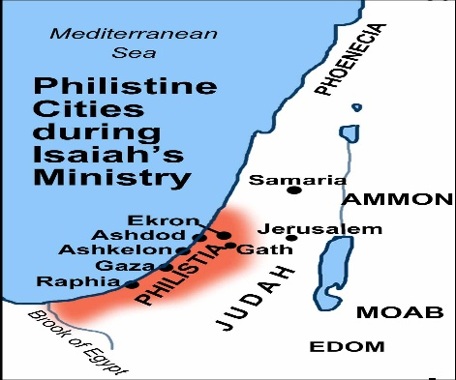

Isaiah 20:1 “In the year that the supreme commander, sent by Sargon king of Assyria, came to Ashdod and attacked and captured it—” The taking of Ashdod by the Assryians would confirm the judgment coming upon Egypt that we learned about in chapter 19. Ashdod was an ally to Egypt and Ethiopia (Cush) and the strongest of the Philistine cities. God was showing the Israelites in Judah and the whole world, that trusting in anyone for your safety and security, except trust in the One True God is hopeless! Ashdod fell to Assyria in 711 BC.

Were you surprised to read what God asked Isaiah to do? Do you think when Isaiah said, “Here am I, send me!” that he had any idea what lay in his future? Probably not. But he meant what he said and would do what the Lord asked of him. He was to walk naked (not completely naked as he would still be wearing his undergarments) and barefoot.

Isaiah 20:3-4 ³ Then the Lord said, “Just as my servant Isaiah has gone stripped and barefoot for three years, as a sign and portent against Egypt and Cush, ⁴ so the king of Assyria will lead away stripped and barefoot the Egyptian captives and Cushite exiles, young and old, with buttocks bared—to Egypt’s shame.”

This short chapter closes with these powerful words: Isaiah 20:5-6 ⁵ Those who trusted in Cush and boasted in Egypt will be dismayed and put to shame. ⁶ In that day the people who live on this coast will say, ‘See what has happened to those we relied on, those we fled to for help and deliverance from the king of Assyria! How then can we escape?’”

As the theologian Robert Morgan said, “There is no place of security for the people of God, other than that to be found in the rule of God. All expectation not centered in God, is doomed to disappointment and discomfiture.”

Think about the great spiritual symbolism of this: God says there is only one way to be saved, to be delivered, through belief in His Son! As the Apostle Peter said of Jesus in Acts 4:12 “Salvation is found in no one else, for there is no other name under heaven given to mankind by which we must be saved.”

Chapter 21 starts with another prophecy against Babylon. This is the third time that God has spoken against Babylon, with the previous two being in chapters 13 and 14.

Isaiah 21:1-2 opens with ¹ A prophecy against the Desert by the Sea: Like
whirlwinds sweeping through the southland, an invader comes from the desert, from a land of terror. ² A dire vision has been shown to me: The traitor betrays, the looter takes loot.
Elam, attack! Media, lay siege! I will bring to an end all the groaning she caused.

Many Bible translations title this section of Scripture, “A prophecy against Babylon.” The word “sea” is also a word that means “large river”, and in this case is a reference to the vast Euphrates River, upon which Babylon was situated.

The prophecy also tells us “who” God will send to bring judgment upon Babylon, the Medes/Persians! Isaiah’s words, “Elam, attack! Media, lay siege!”, is clear, Elam was conquered by the Medes, who were themselves were conquered by the Persian King Cyrus. This prophecy, the fall of Babylon took place in 539 BC, some 150 years after the prophecy.
While this judgment upon Babylon was certainly justified because of Babylon’s continued depravity, we see how this vision impacted Isaiah: My body is racked with pain … I am staggered by what I hear … I am bewildered by what I see … fear makes me tremble. It also impacts the heart of God. While His judgments are perfect, God says in Ezekiel 18:23 “Do I take any pleasure in the death of the wicked? declares the Sovereign Lord. Rather, am I not pleased when they turn from their ways and live?”

The last two prophecies in chapter 21 deal with Edom and Arabia. Dumah was a son of Ishmael and most probably the founder of the Ishmaelite tribe of Arabia. Kedar was also a son of Ishmael and a leader of a nomadic tribe in Arabia. Most believe this prophecy was a reference to the Assyrians coming against Edom and not the later siege by the Babylonians. The prophecy warns in Isaiah 21:16 that, “Within one year, as a servant bound by contract would count it, all the splendor of Kedar will come to an end.” History shows through Assyrian inscriptions that Edom and the surrounding Arabian tribes became a vassal state of Assyria.

So, what are we, some 2,700 years after all these prophecies, to learn from them?

- That God always warns before judgment, not only what is to come, but why. That’s why we study our Bible – to know the plan of God for the future. We know what pleases Him and what does not. That knowledge prepares us to avoid the coming judgments of the Book of Revelation.
- God is in full control. When life has us worrying about how things will turn out, we remember that very important fact.
- When they cry out to the Lord because of their oppressors, He will send them a savior and defender, and He will rescue them. Sin is the great oppressor, and we find deliverance by the blood of the Lord Jesus Christ, our Savior.
- God uses obedient people, like Isaiah, to accomplish His will. We know that God’s will is that everyone should repent and be saved, and we’re to be His voice to a lost and dying world.

I’ll leave you with these thoughts:

“God is not human, that He should lie, not a human being, that He should change His mind. Does He speak and then not act? Does He promise and not fulfill?” Numbers 23:19

God’s Words and His promises are true and certain! God says, "I have spoken, and I will bring it to pass; I have purposed, and I will do it." Isaiah 46:11

Let’s pray!

