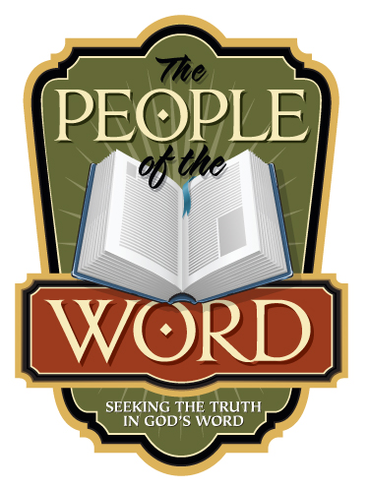
CHURCH HISTORY – THE FIRST THOUSAND YEARS
See peopleoftheword.online (Archive)
Writer: Laurel Porro
Presenter: Laura Rutherford

Biographies: See peopleoftheword.online (Archive)
William Tyndale 1494-1536

John Calvin 1509-1564

